电梯曳引性能测试仪APP

开发及部署文档

1.开发 2

1.1源码结构 2

1.2模块说明 3

1.2.1入口文件 3

1.2.2功能模块 5

1.2.2.1功能选择 7

1.2.2.2通讯检测 28

1.2.2.3数据查询 30

1.2.3辅助模块及公式计算 30

2.部署 33

2.1环境搭建 33

2.1.1下载Android Studio 33

2.1.2 SDK下载 33

2.2源码编译 35

# 1.开发

## 1.1源码结构

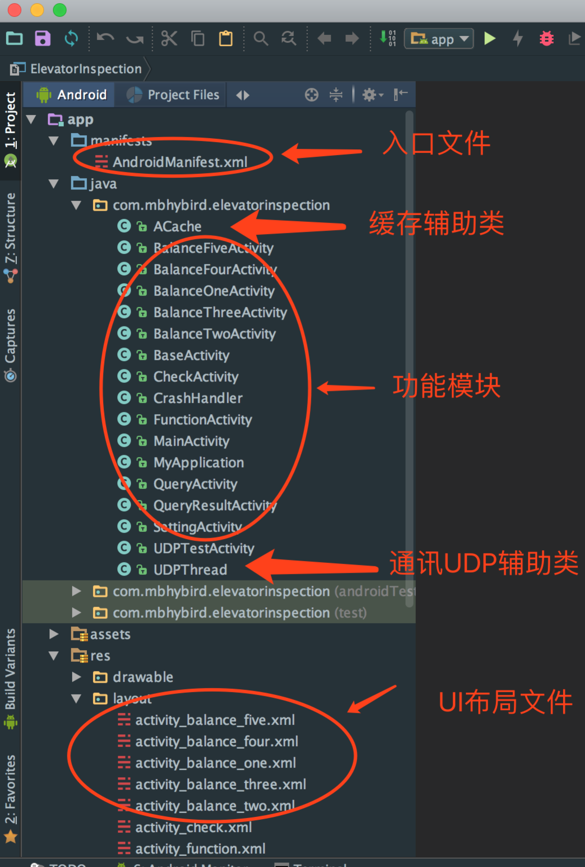

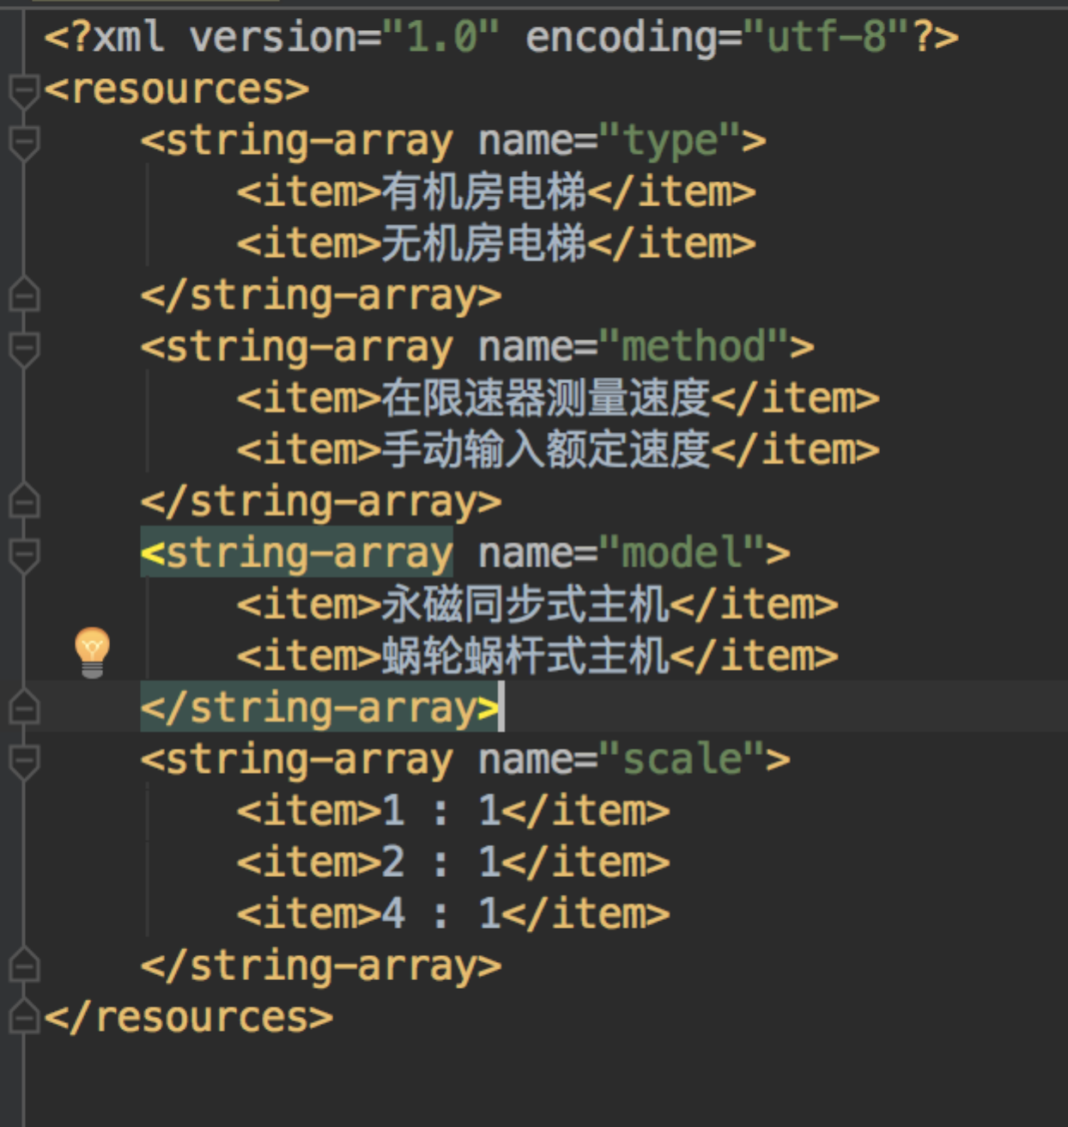

下拉框数据初始化设定

## 1.2模块说明

### 1.2.1入口文件

AndroidManifest.xml

<?xml version="1.0" encoding="utf-8"?>  
<manifest xmlns:android="http://schemas.android.com/apk/res/android"  
 package="com.mbhybird.elevatorinspection">  
  
 <uses-permission android:name="android.permission.INTERNET" />  
 <uses-permission android:name="android.permission.ACCESS_WIFI_STATE" />  
 <uses-permission android:name="android.permission.WRITE_EXTERNAL_STORAGE" />  
  
 <application  
 android:name=".MyApplication"  
 android:allowBackup="true"  
 android:icon="@drawable/lift"  
 android:label="@string/app_name"  
 android:largeHeap="true"  
 android:roundIcon="@drawable/lift"  
 android:supportsRtl="true"  
 android:theme="@style/AppTheme">  
 <activity  
 android:name=".MainActivity"  
 android:screenOrientation="portrait">  
 <intent-filter>  
 <action android:name="android.intent.action.MAIN" />  
 <category android:name="android.intent.category.LAUNCHER" />  
 </intent-filter>  
 </activity>  
 <activity  
 android:name=".UDPTestActivity"  
 android:screenOrientation="portrait">  
 <!--<intent-filter>-->  
 <!--<action android:name="android.intent.action.MAIN" />-->  
 <!--<category android:name="android.intent.category.LAUNCHER" />-->  
 <!--</intent-filter>-->  
 </activity>  
 <activity  
 android:name=".FunctionActivity"  
 android:screenOrientation="portrait" />  
 <activity  
 android:name=".QueryActivity"  
 android:screenOrientation="portrait" />  
 <activity  
 android:name=".CheckActivity"  
 android:screenOrientation="portrait" />  
 <activity  
 android:name=".SettingActivity"  
 android:screenOrientation="portrait" />  
 <activity  
 android:name=".QueryResultActivity"  
 android:screenOrientation="portrait" />  
 <activity  
 android:name=".BalanceOneActivity"  
 android:screenOrientation="portrait" />  
 <activity  
 android:name=".BalanceTwoActivity"  
 android:screenOrientation="portrait" />  
 <activity  
 android:name=".BalanceThreeActivity"  
 android:screenOrientation="portrait" />  
 <activity  
 android:name=".BalanceFourActivity"  
 android:screenOrientation="portrait" />  
 <activity  
 android:name=".BalanceFiveActivity"  
 android:screenOrientation="portrait" />  
 </application>  
  
</manifest>

入口文件加入网络权限，读写SD卡权限，启动文件指向MainActivity.java

### 1.2.2功能模块

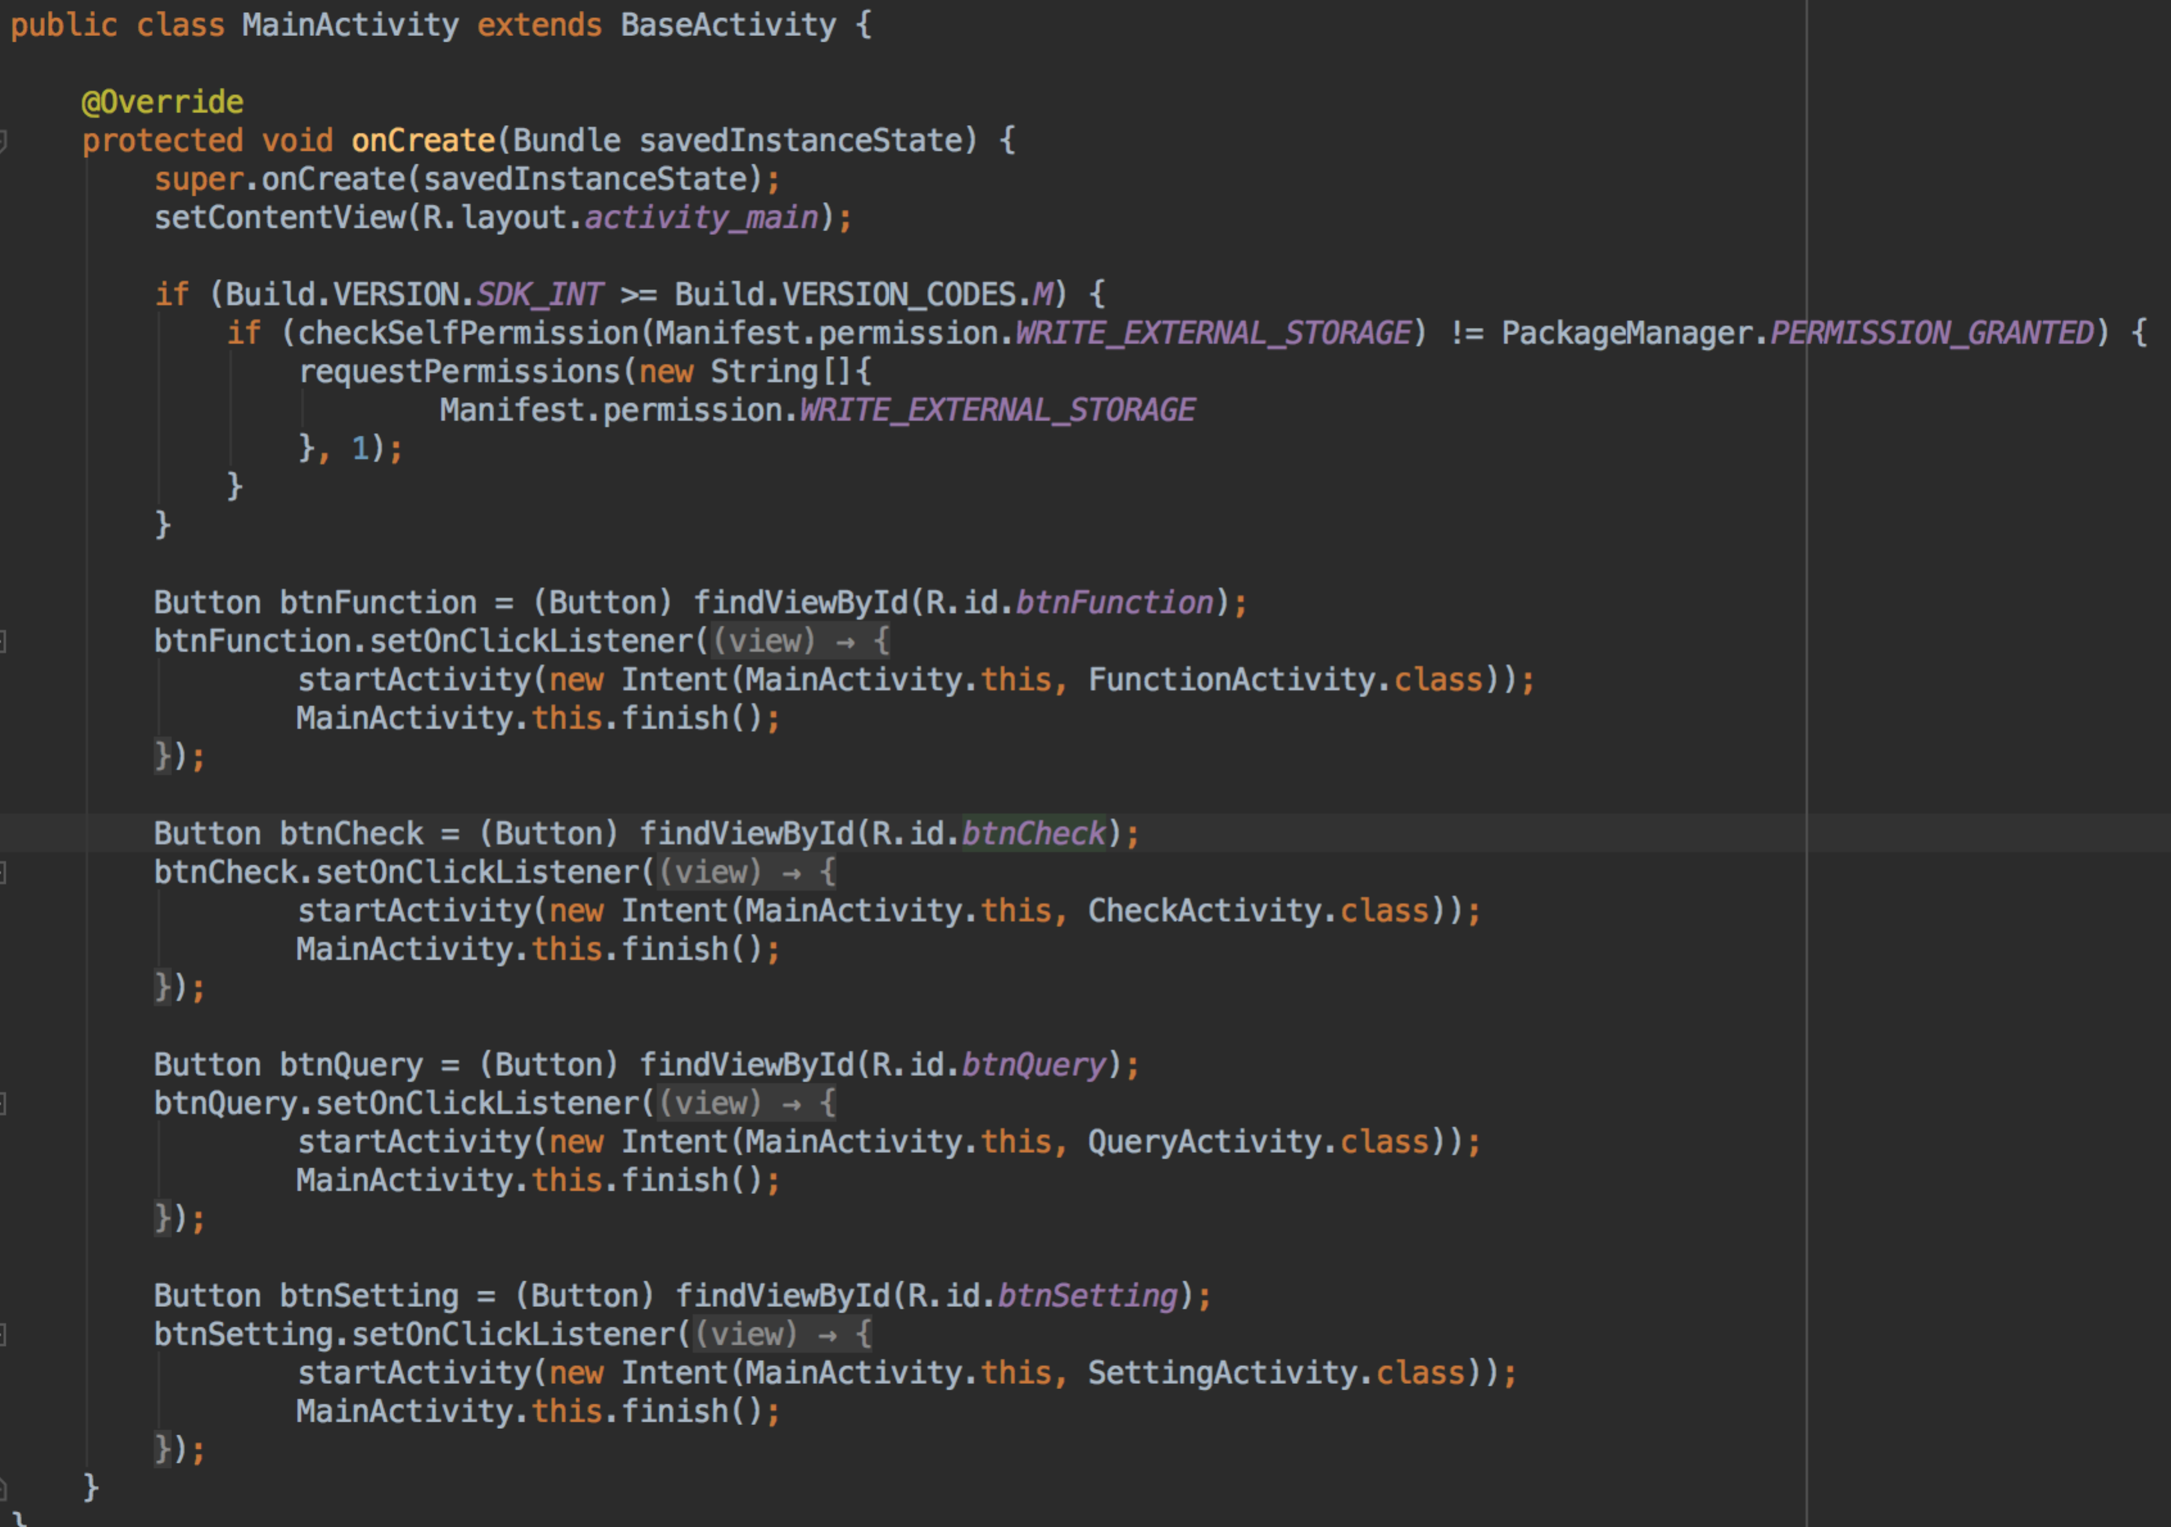

Android(M) 6.0版本的设置要动态设置权限

功能模块划分为3个

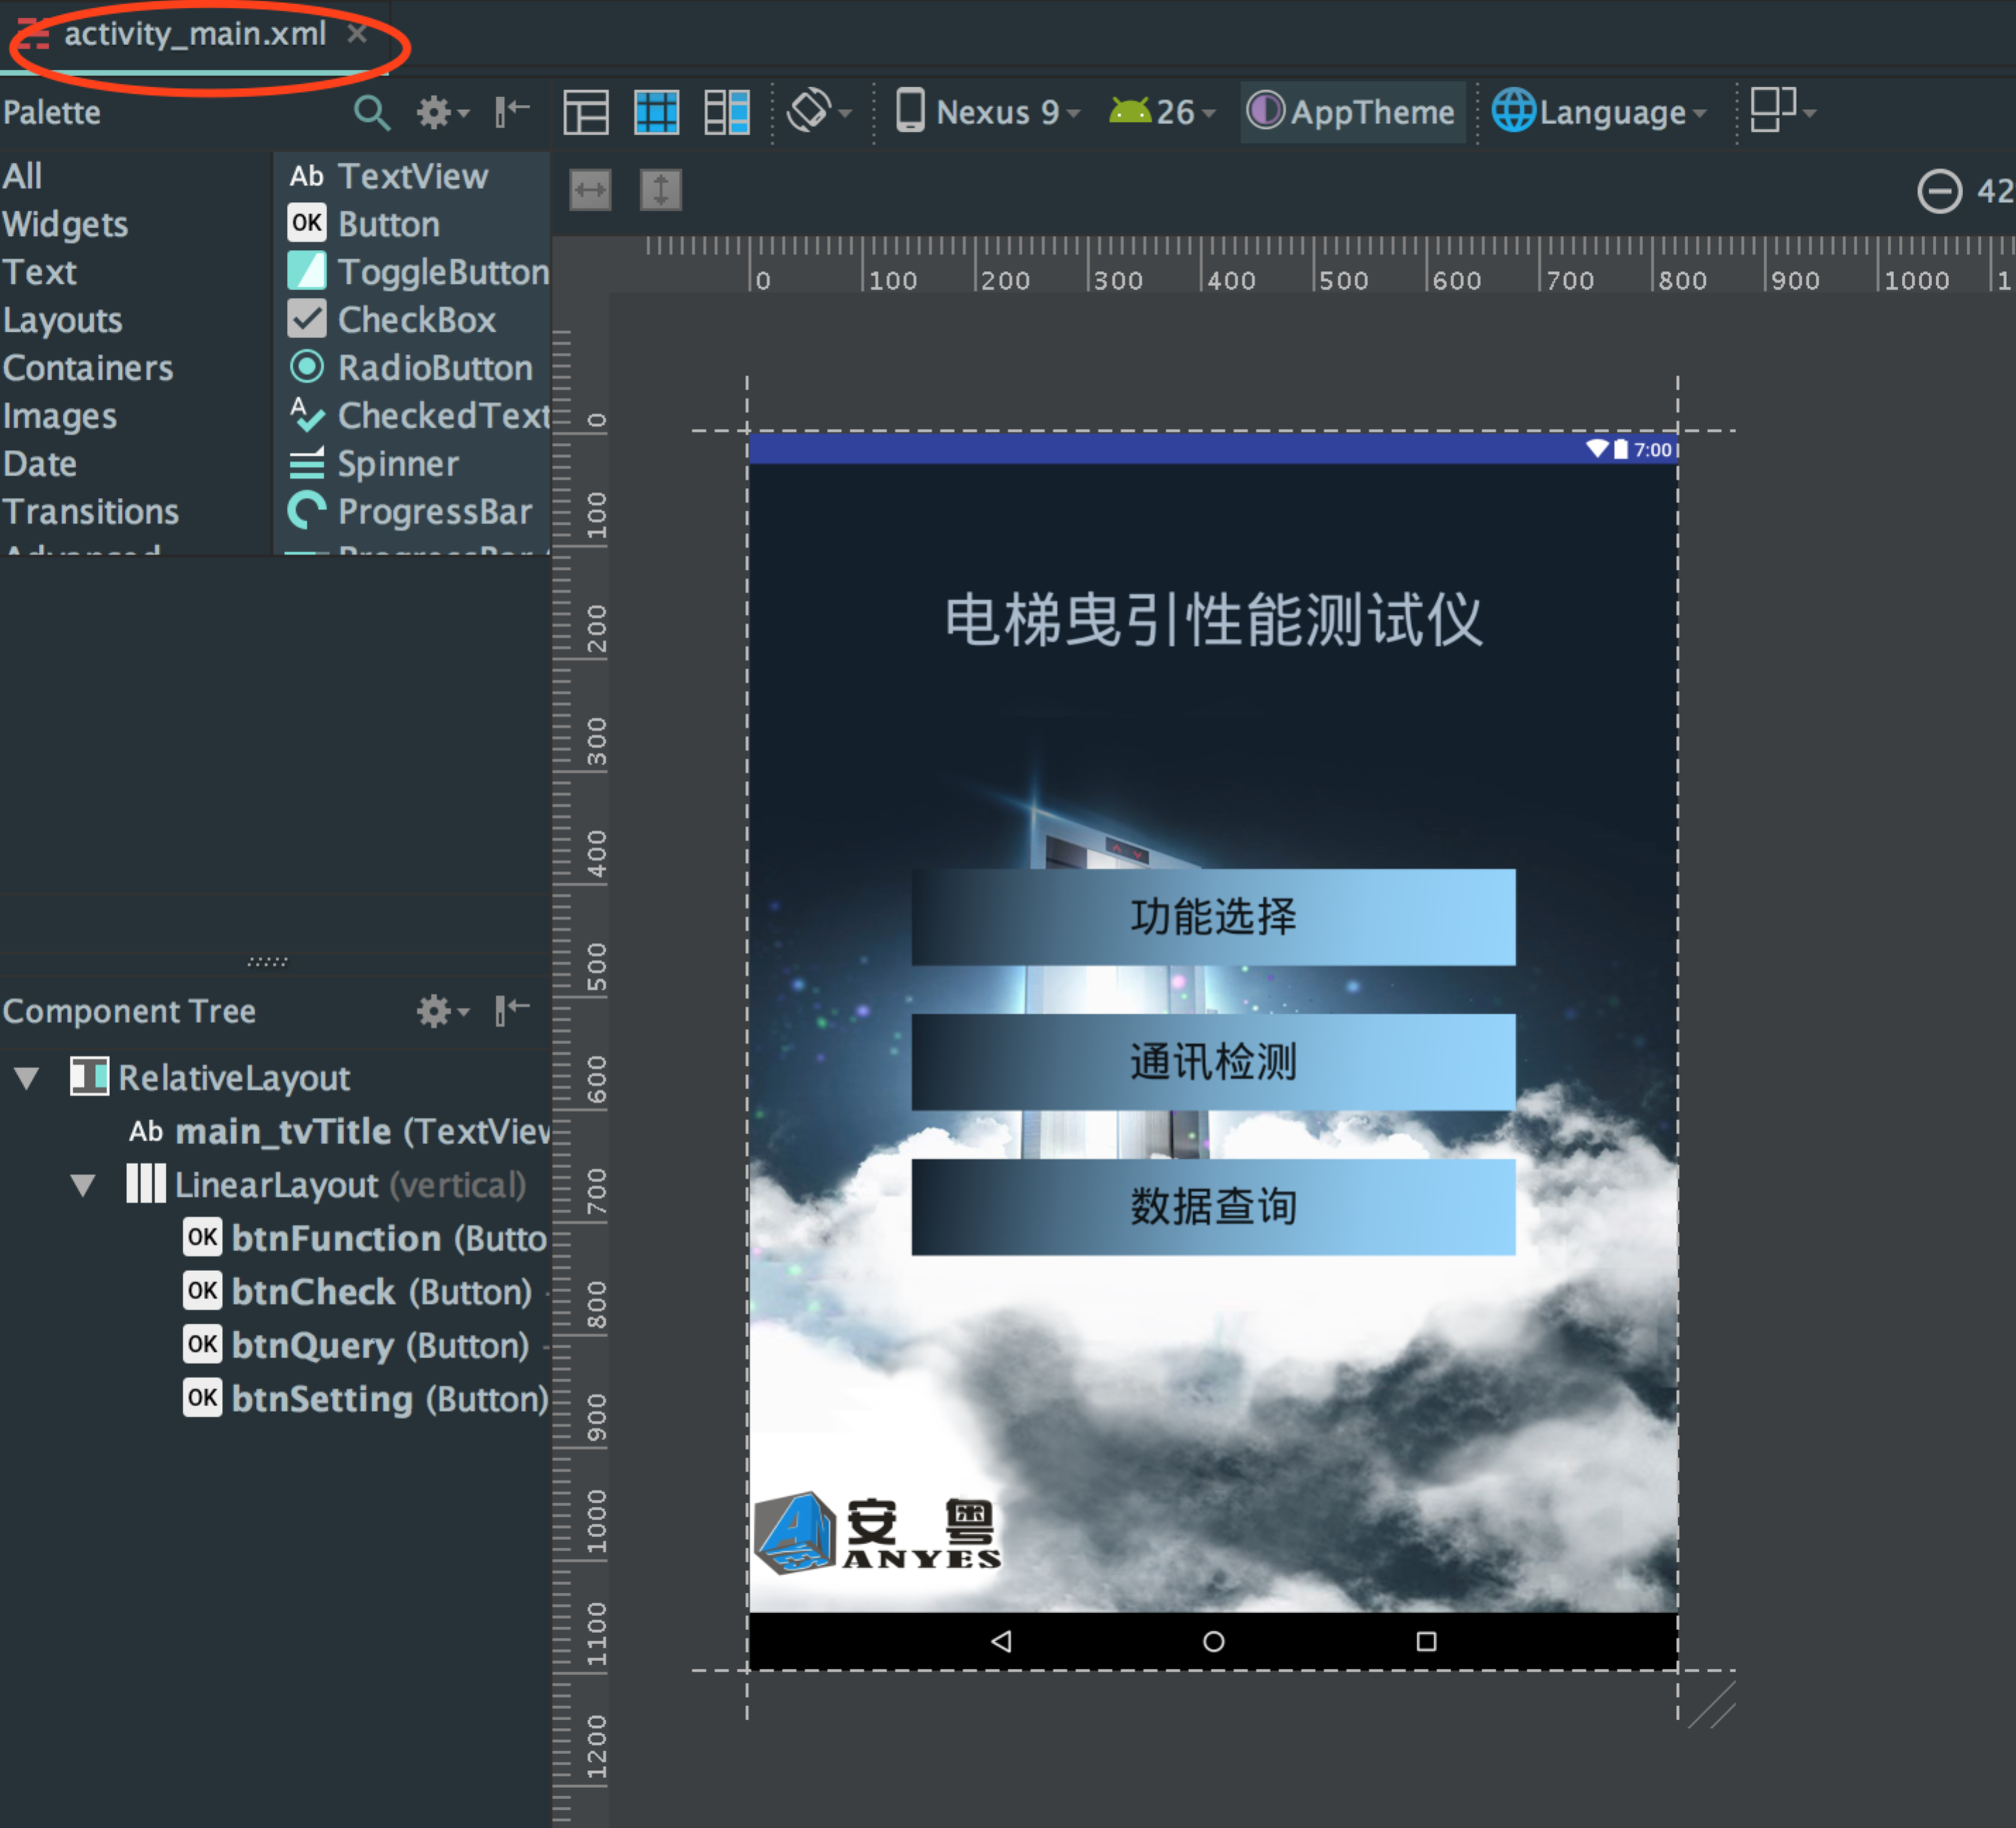

#### 1.2.2.1功能选择

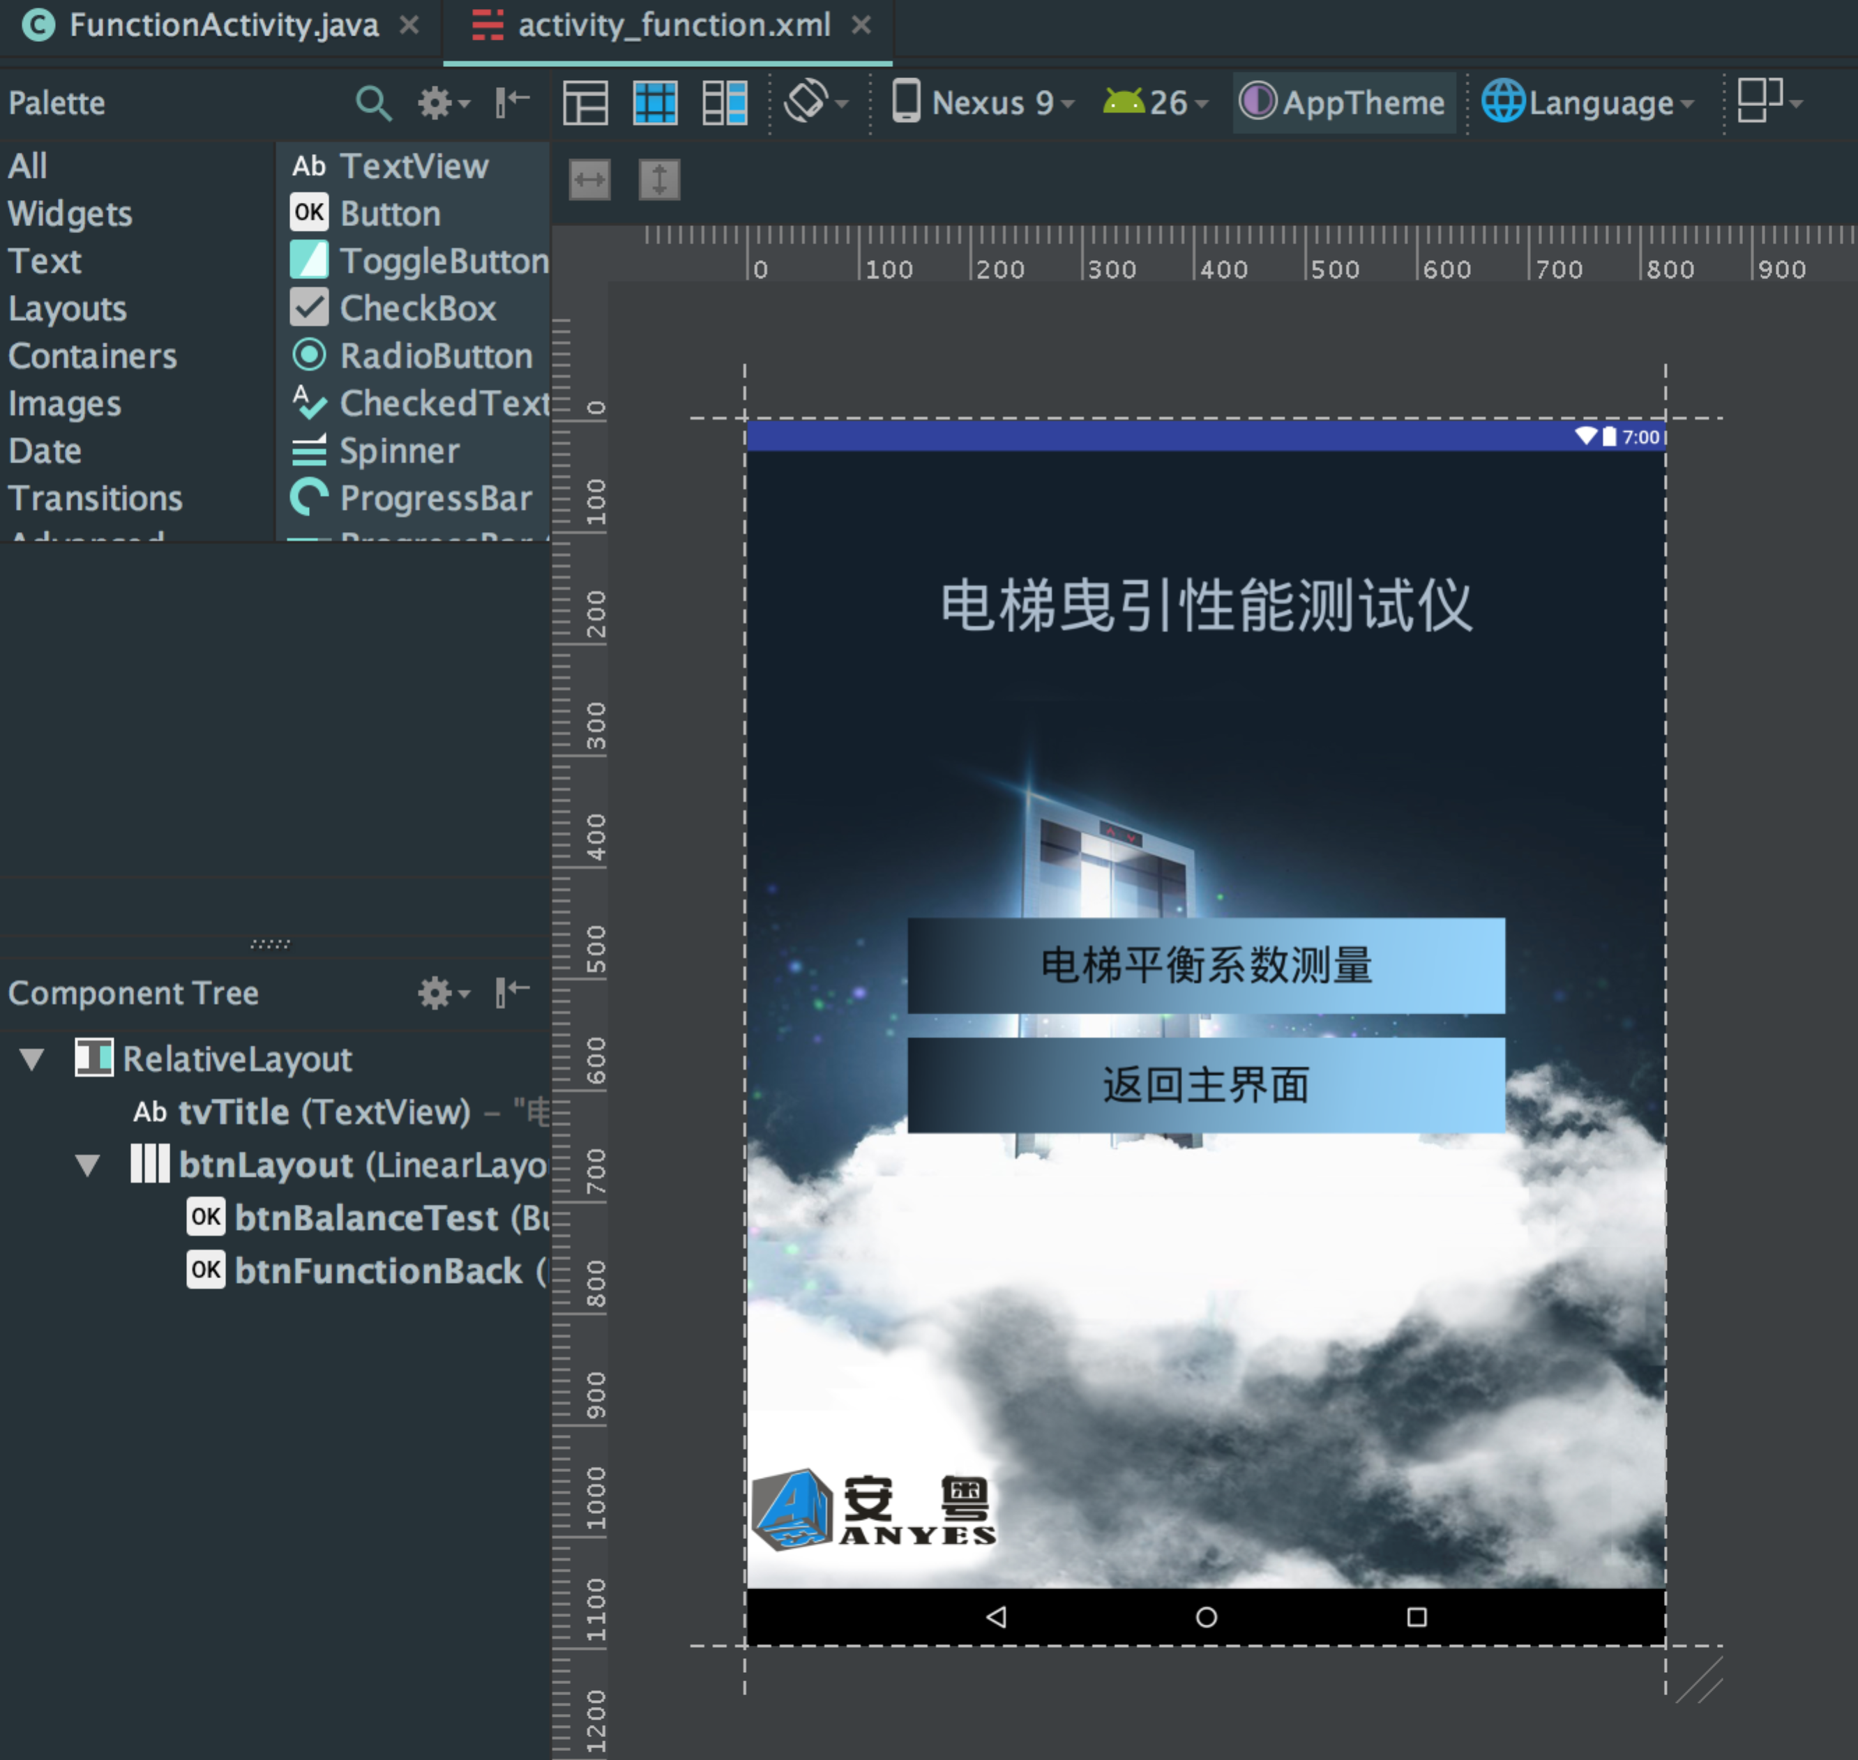

电梯平衡系数测量，含五个功能界面，分别one,two,three,four,five布局和代码

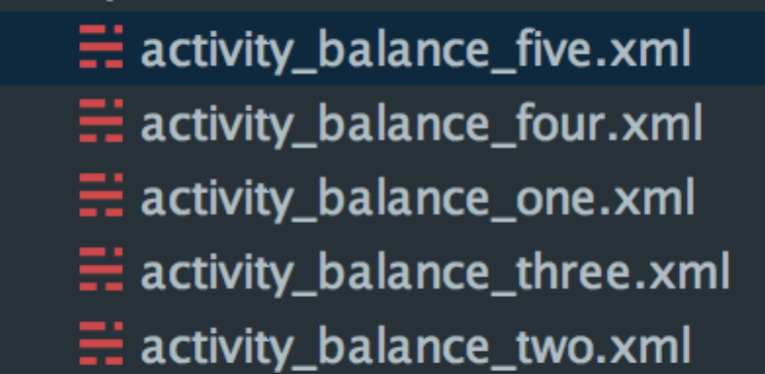

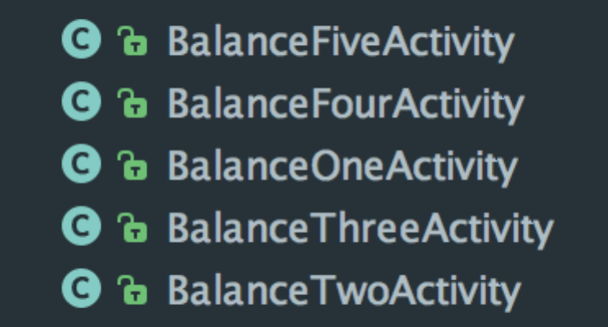

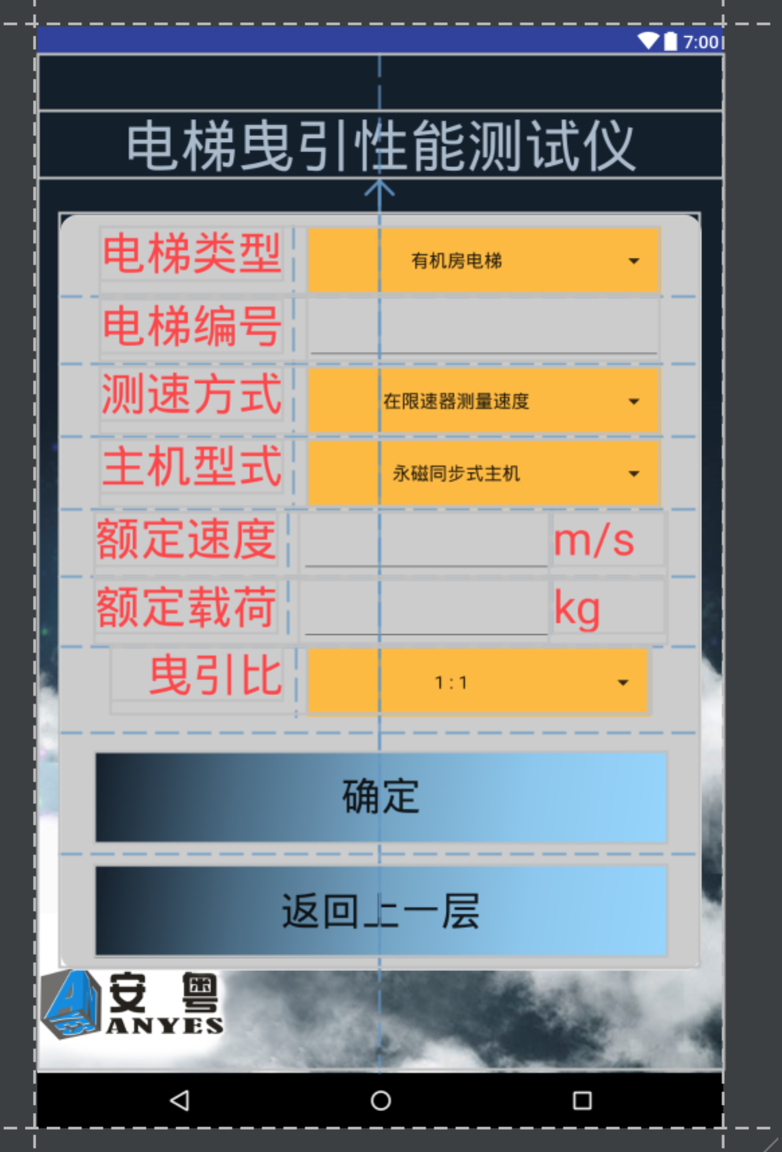

代码片段：

final Spinner spMethod = (Spinner) findViewById(R.id.*spMethod*);  
  
 Button btnBack = (Button) findViewById(R.id.*btnBalanceOneBack*);  
 btnBack.setOnClickListener(new View.OnClickListener() {  
 @Override  
 public void onClick(View view) {  
 startActivity(new Intent(BalanceOneActivity.this, FunctionActivity.class));  
 BalanceOneActivity.this.finish();  
 }  
 });  
  
 final EditText etLoad = (EditText) findViewById(R.id.*one_et_load*);  
 final EditText etNumber = (EditText) findViewById(R.id.*one_et_number*);  
 final EditText etManualSpeed = (EditText) findViewById(R.id.*one_et_manualSpeed*);  
  
 Button btnBalanceOneOK = (Button) findViewById(R.id.*btnBalanceOneOK*);  
 btnBalanceOneOK.setOnClickListener(new View.OnClickListener() {  
 @Override  
 public void onClick(View view) {  
 if (TextUtils.*isEmpty*(etNumber.getText().toString())) {  
 showAlert("编号必须输入，请检查!");  
 return;  
 }  
 if (TextUtils.*isEmpty*(etLoad.getText().toString())) {  
 showAlert("载荷必须输入，请检查!");  
 return;  
 }  
 myApp.TestSpeedMethod = spMethod.getSelectedItem().toString();  
 Log.*i*(*TAG*, myApp.TestSpeedMethod);  
 myApp.mLoad = Float.*valueOf*(etLoad.getText().toString());  
 myApp.writeLog(String.*format*("mLoad:%s", myApp.mLoad));  
  
 if(myApp.mIsManualSpeed) {  
 if (TextUtils.*isEmpty*(etManualSpeed.getText().toString())) {  
 showAlert("额定速度必须输入，请检查!");  
 return;  
 }  
  
 float manualSpeed = Float.*valueOf*(etManualSpeed.getText().toString());  
 if (manualSpeed > 0) {  
 myApp.mManualSpeed = manualSpeed;  
 myApp.writeLog(String.*format*("mManualSpeed:%s", myApp.mManualSpeed));  
 } else {  
 showAlert("额定速度必须大于0，请检查!");  
 return;  
 }  
 }  
  
 SimpleDateFormat sdf = new SimpleDateFormat("yyyyMMdd");  
 myApp.mNumber = etNumber.getText().toString();  
 myApp.mDate = sdf.format(new Date());  
 ACache.*get*(BalanceOneActivity.this).put(myApp.mNumber, "");  
 ACache.*get*(BalanceOneActivity.this).put(myApp.mDate, "");  
  
 startActivity(new Intent(BalanceOneActivity.this, BalanceTwoActivity.class));  
 BalanceOneActivity.this.finish();  
 }  
 });  
  
 //init  
 Spinner spType = (Spinner) findViewById(R.id.*spType*);  
 Spinner spModel = (Spinner) findViewById(R.id.*spModel*);  
 final Spinner spScale = (Spinner) findViewById(R.id.*spScale*);  
 final ArrayAdapter spScaleAd = ArrayAdapter.*createFromResource*(this,  
 R.array.*scale*, R.layout.*custom_spiner_text_item*);  
 spScaleAd.setDropDownViewResource(R.layout.*custom_spinner_dropdown_item*);  
 spModel.setOnItemSelectedListener(new AdapterView.OnItemSelectedListener() {  
 @Override  
 public void onItemSelected(AdapterView<?> adapterView, View view, int i, long l) {  
 if (i == 0) {  
 myApp.mElevator = 1f;  
 } else {  
 myApp.mElevator = 1f;  
 }  
 }  
  
 @Override  
 public void onNothingSelected(AdapterView<?> adapterView) {  
  
 }  
 });  
 spType.setOnItemSelectedListener(new AdapterView.OnItemSelectedListener() {  
 @Override  
 public void onItemSelected(AdapterView<?> adapterView, View view, int i, long l) {  
 spMethod.setSelection(i);  
 spScale.setEnabled(i == 0);  
 if (i == 0) {  
 spScale.setAdapter(spScaleAd);  
 } else {  
 spScale.setAdapter(null);  
 }  
 }  
  
 @Override  
 public void onNothingSelected(AdapterView<?> adapterView) {  
  
 }  
 });  
  
 // 通过加载xml文件配置的数据源  
 ArrayAdapter spTypeAd = ArrayAdapter.*createFromResource*(this,  
 R.array.*type*, R.layout.*custom_spiner_text_item*);  
 spTypeAd.setDropDownViewResource(R.layout.*custom_spinner_dropdown_item*);  
 spType.setAdapter(spTypeAd);  
  
 ArrayAdapter spMethodAd = ArrayAdapter.*createFromResource*(this,  
 R.array.*method*, R.layout.*custom_spiner_text_item*);  
 spMethodAd.setDropDownViewResource(R.layout.*custom_spinner_dropdown_item*);  
 spMethod.setAdapter(spMethodAd);  
  
 spMethod.setOnItemSelectedListener(new AdapterView.OnItemSelectedListener() {  
 @Override  
 public void onItemSelected(AdapterView<?> adapterView, View view, int i, long l) {  
 if (i == 0) {  
 myApp.mIsManualSpeed = false;  
 } else {  
 myApp.mIsManualSpeed = true;  
 }  
 }  
  
 @Override  
 public void onNothingSelected(AdapterView<?> adapterView) {  
  
 }  
 });  
  
 ArrayAdapter spModelAd = ArrayAdapter.*createFromResource*(this,  
 R.array.*model*, R.layout.*custom_spiner_text_item*);  
 spModelAd.setDropDownViewResource(R.layout.*custom_spinner_dropdown_item*);  
 spModel.setAdapter(spModelAd);  
  
 spScale.setAdapter(spScaleAd);  
 spScale.setOnItemSelectedListener(new AdapterView.OnItemSelectedListener() {  
 @Override  
 public void onItemSelected(AdapterView<?> adapterView, View view, int i, long l) {  
 if (i == 0) {  
 myApp.mTractProp = 1f;  
 } else if (i == 1) {  
 myApp.mTractProp = 1f;  
 } else {  
 myApp.mTractProp = 1f;  
 }  
 }  
  
 @Override  
 public void onNothingSelected(AdapterView<?> adapterView) {  
  
 }  
 });  
}

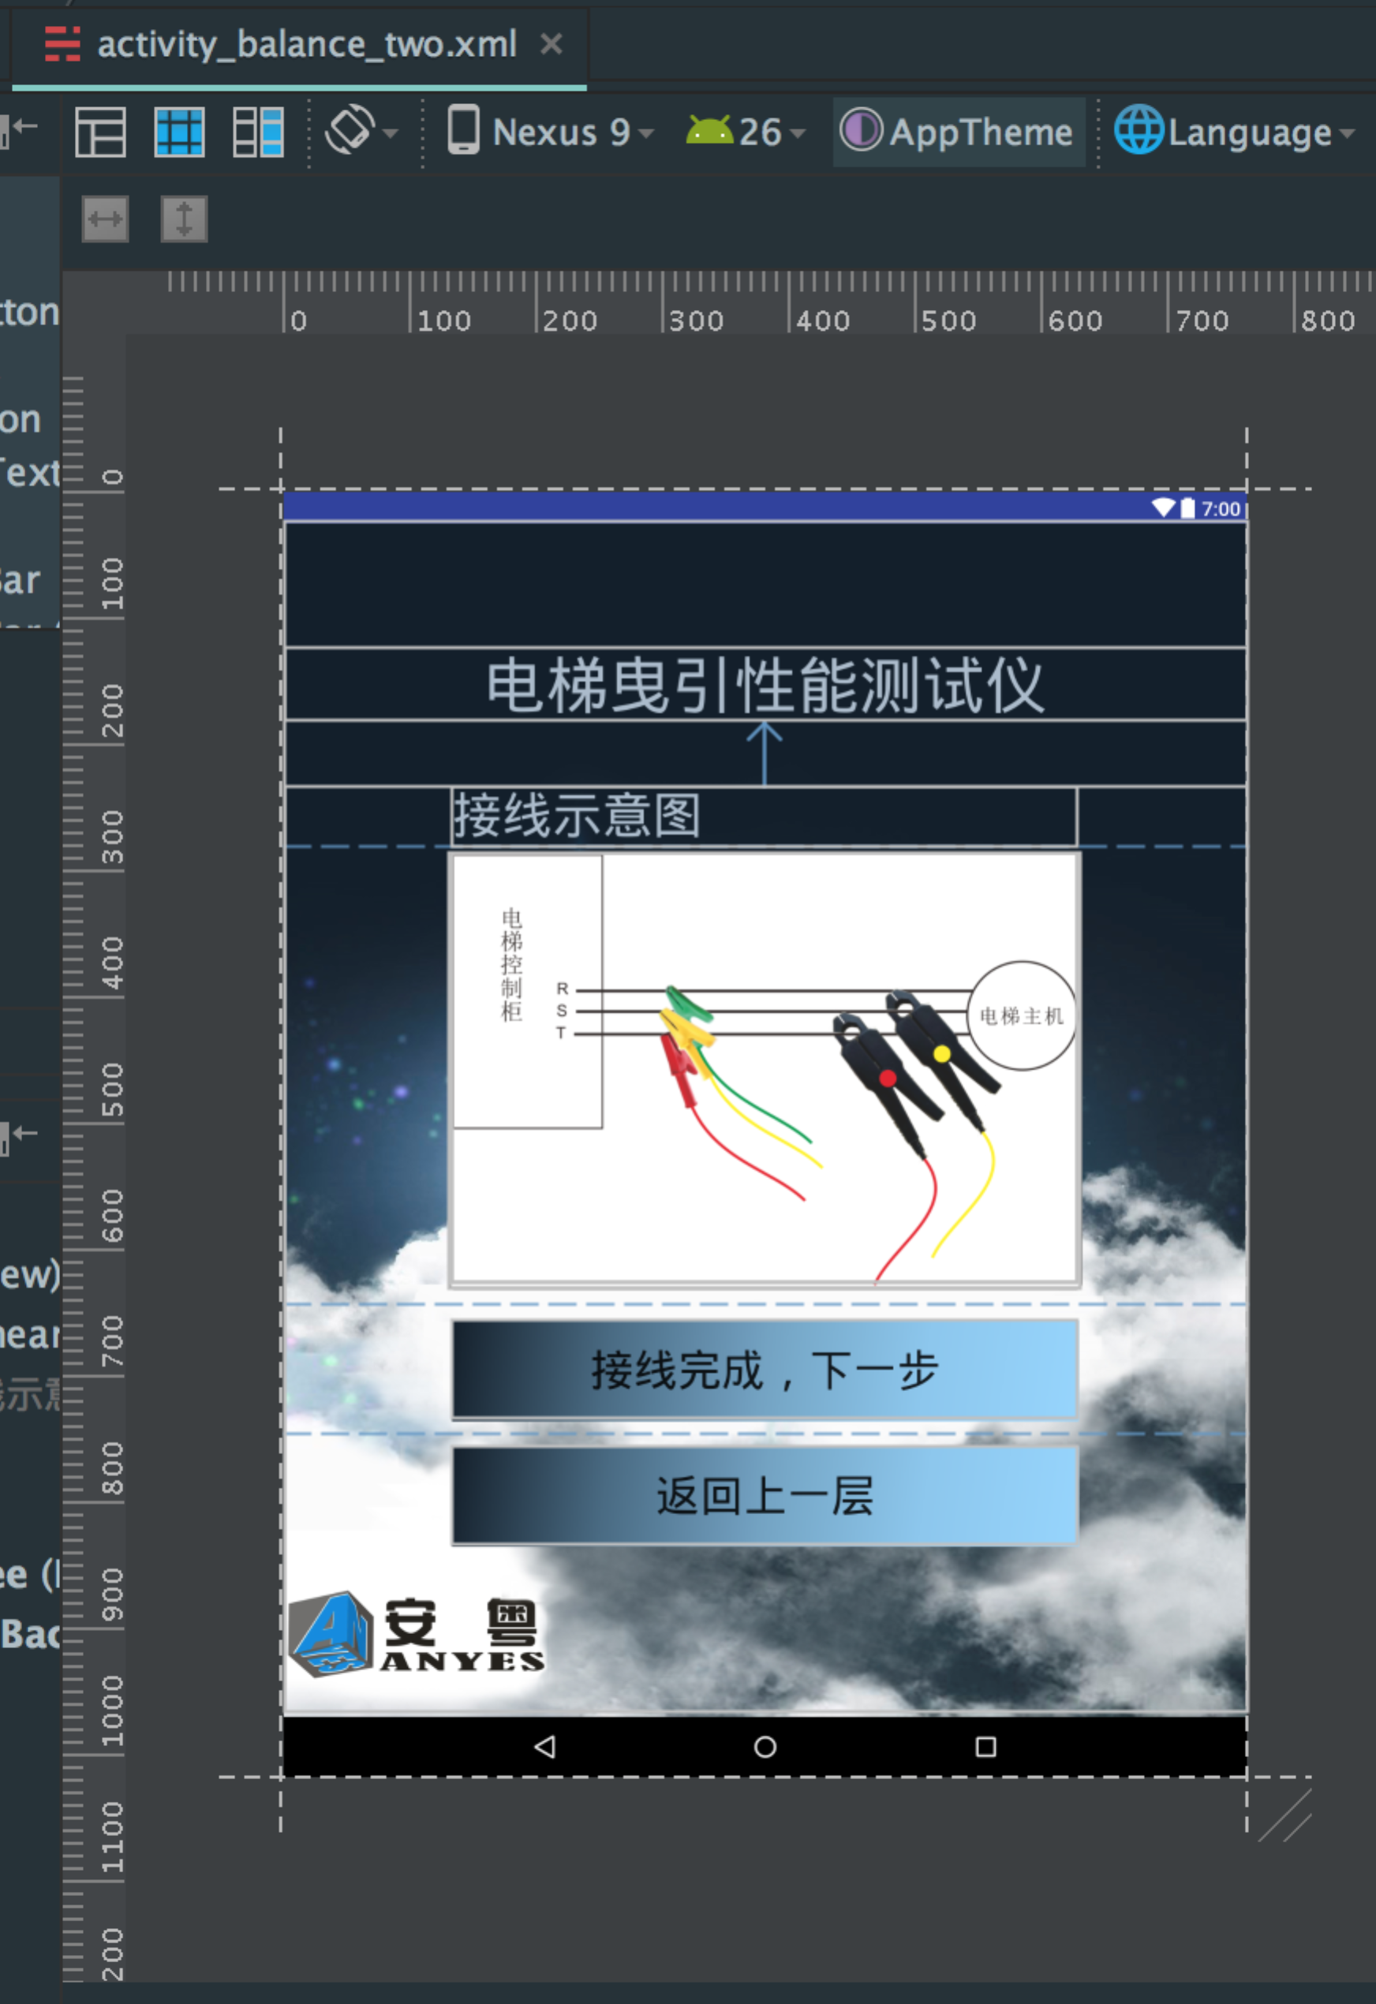

代码片段：

Button btnBack = (Button) findViewById(R.id.*btnBalanceTwoBack*);  
 btnBack.setOnClickListener(new View.OnClickListener() {  
 @Override  
 public void onClick(View view) {  
 startActivity(new Intent(BalanceTwoActivity.this, BalanceOneActivity.class));  
 BalanceTwoActivity.this.finish();  
 }  
 });  
  
 Button btnBalanceThree = (Button) findViewById(R.id.*btnBalanceThree*);  
 btnBalanceThree.setOnClickListener(new View.OnClickListener() {  
 @Override  
 public void onClick(View view) {  
 startActivity(new Intent(BalanceTwoActivity.this, BalanceThreeActivity.class));  
 BalanceTwoActivity.this.finish();  
 }  
 });  
}

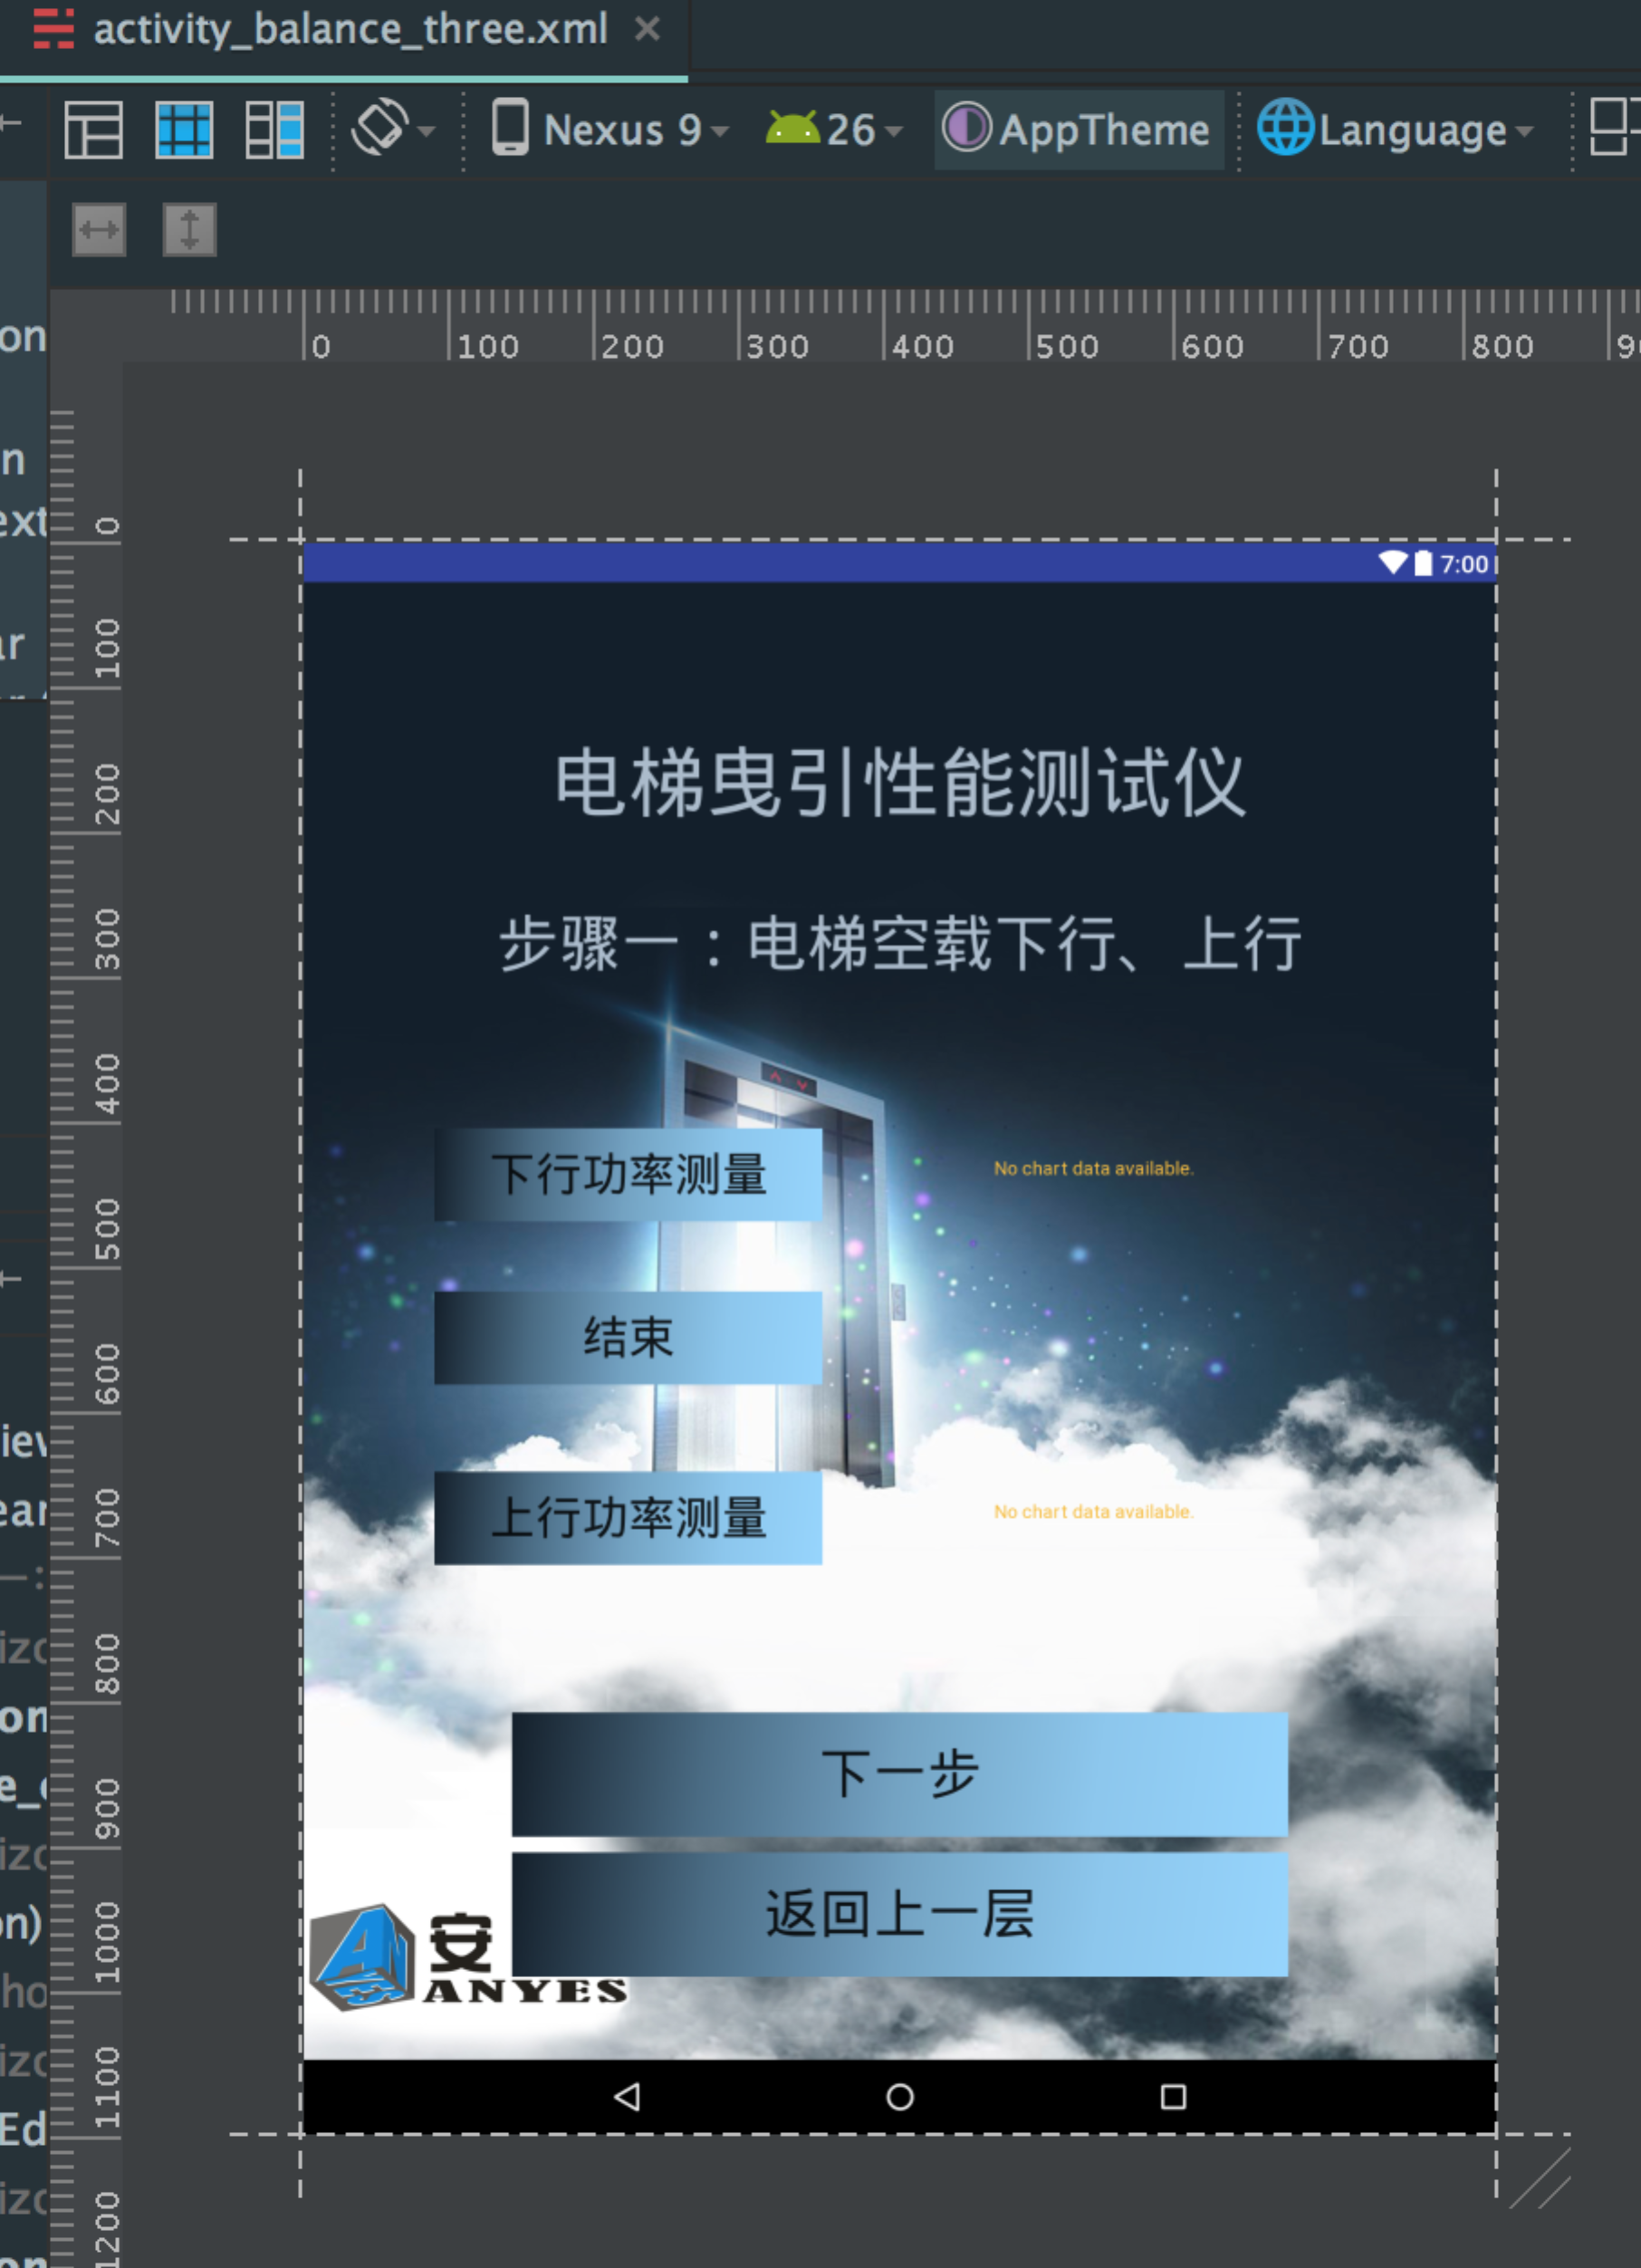

代码片段：

发送信号测试，结束后画图。

@Override  
 protected void onCreate(Bundle savedInstanceState) {  
 super.onCreate(savedInstanceState);  
 setContentView(R.layout.*activity_balance_three*);  
  
 mWifiManager = (WifiManager) getApplicationContext().getSystemService(Context.*WIFI_SERVICE*);  
  
 Button btnBack = (Button) findViewById(R.id.*btnBalanceThreeBack*);  
 btnBack.setOnClickListener(new View.OnClickListener() {  
 @Override  
 public void onClick(View view) {  
 startActivity(new Intent(BalanceThreeActivity.this, BalanceTwoActivity.class));  
 BalanceThreeActivity.this.finish();  
 }  
 });  
  
 Button btnBalanceFour = (Button) findViewById(R.id.*btnBalanceFour*);  
 btnBalanceFour.setOnClickListener(new View.OnClickListener() {  
 @Override  
 public void onClick(View view) {  
 startActivity(new Intent(BalanceThreeActivity.this, BalanceFourActivity.class));  
 BalanceThreeActivity.this.finish();  
 }  
 });  
  
 btnUPowerMon = (Button) findViewById(R.id.*btnUPowerMon*);  
 btnDPowerMon = (Button) findViewById(R.id.*btnDPowerMon*);  
 etUDPower = (EditText) findViewById(R.id.*et_udPower*);  
 pb = (ProgressBar) findViewById(R.id.*three_check_pb*);  
 btnEnd = (Button) findViewById(R.id.*btnEnd*);  
 btnEnd.setEnabled(false);  
  
 ut = new UDPThread(etUDPower, myApp.RecDataList);  
 ut.setRemoteIP("255.255.255.255");  
 ut.setRemotePort(8432);  
 ut.setLocalPort(8432);  
 ut.setRHex(true);  
 ut.setSHex(true);  
  
 mUPChart = (LineChart) findViewById(R.id.*balance_three_chart_UPower*);  
 mUPChart.getDescription().setEnabled(false);  
 mUPChart.setNoDataText("");  
 mUPChart.setBackgroundColor(Color.*WHITE*);  
 mUPChart.setDrawGridBackground(true);  
 YAxis uLeftAxis = mUPChart.getAxisLeft();  
 uLeftAxis.setAxisMaximum(20000f);  
 uLeftAxis.setAxisMinimum(0f);  
 mUPChart.getAxisRight().setEnabled(false);  
 XAxis uXAxis = mUPChart.getXAxis();  
 uXAxis.setEnabled(false);  
  
 mDPChart = (LineChart) findViewById(R.id.*balance_three_chart_DPower*);  
 mDPChart.getDescription().setEnabled(false);  
 mDPChart.setDrawGridBackground(true);  
 mDPChart.setBackgroundColor(Color.*WHITE*);  
 mDPChart.setNoDataText("");  
 YAxis dLeftAxis = mDPChart.getAxisLeft();  
 dLeftAxis.setAxisMaximum(20000f);  
 dLeftAxis.setAxisMinimum(0f);  
 mDPChart.getAxisRight().setEnabled(false);  
 XAxis dXAxis = mDPChart.getXAxis();  
 dXAxis.setEnabled(false);  
  
 btnUPowerMon.setOnClickListener(new View.OnClickListener() {  
 @Override  
 public void onClick(View view) {  
 myApp.mUPower = 0f;  
 myApp.mUPowerFactor = 0f;  
 setTypeThenDraw("UP");  
  
// //for test  
// mTestType = "DOWN";  
// btnUPowerMon.setEnabled(false);  
// btnEnd.setEnabled(true);  
// btnDPowerMon.setEnabled(false);  
// etUDPower.getText().clear();  
// myApp.RecDataList.clear();  
// myApp.RecDataList.add("AA040102"+"000000"+"111111"+"111111111111111111");  
// myApp.RecDataList.add("AA040102"+"010000"+"111111"+"111111111111111111");  
// myApp.RecDataList.add("AA040102"+"010000"+"111111"+"111111111111111111");  
// myApp.RecDataList.add("AA040102"+"010000"+"111111"+"111111111111111111");  
// myApp.RecDataList.add("AA040102"+"010000"+"111111"+"111111111111111111");  
// myApp.RecDataList.add("AA040102"+"011000"+"111111"+"111111111111111111");  
// myApp.RecDataList.add("AA040102"+"022100"+"111111"+"111111111111111111");  
// myApp.RecDataList.add("AA040102"+"032110"+"111111"+"111111111111111111");  
// myApp.RecDataList.add("AA040102"+"032110"+"111111"+"111111111111111111");  
 }  
 });  
  
 btnDPowerMon.setOnClickListener(new View.OnClickListener() {  
 @Override  
 public void onClick(View view) {  
 myApp.mDPower = 0f;  
 myApp.mDPowerFactor = 0f;  
 setTypeThenDraw("DOWN");  
 }  
 });  
  
 btnEnd.setOnClickListener(new View.OnClickListener() {  
 @Override  
 public void onClick(View view) {  
 btnEnd.setEnabled(false);  
 ut.SendData("5501040308");  
 new Handler().postDelayed(new Runnable() {  
 @Override  
 public void run() {  
 ut.DisConnectSocket();  
 pb.setVisibility(View.*INVISIBLE*);  
 btnUPowerMon.setEnabled(true);  
 btnDPowerMon.setEnabled(true);  
 List<Entry> entries = new ArrayList<Entry>();  
 int i = 0;  
 int pos = 0;  
 if (mTestType == "UP") {  
 ArrayList<Float> data = new ArrayList<>();  
 for (String s : myApp.RecDataList) {  
 //totally 19 bytes  
 if (s.length() == 38 && s.startsWith("AA040102")) {  
 //高位  
 float hightVal = strToInt(s.substring(8, 10)) * 100;  
 //中位  
 float midVal = strToInt(s.substring(10, 12));  
 //低位  
 float lowVal = strToFloat(s.substring(12, 14));  
 //增大3倍  
 entries.add(new Entry(i, (hightVal + midVal + lowVal)));  
 Log.*i*("Balance", hightVal + midVal + lowVal + "");  
 i++;  
  
  
 //功率因素  
 //高位  
 float hFactor = strToInt(s.substring(14, 16));  
 //中位  
 float mFactor = strToInt(s.substring(16, 18)) * 0.01f;  
 //低位  
 float lFactor = strToInt(s.substring(18, 20)) * 0.0001f;  
  
 if(hightVal + midVal + lowVal > 0) {  
 float compValue = hightVal + midVal + lowVal;  
 myApp.writeLog(String.*format*("mUPower：%s", compValue));  
 data.add(hightVal + midVal + lowVal);  
 }  
// if (hightVal + midVal + lowVal > 0) {  
// pos++;  
// //取5个后的最大值  
// if (pos > 5) {  
// float compValue = hightVal + midVal + lowVal;  
// myApp.writeLog(String.format("mUPower:%s", compValue));  
// myApp.writeLog(String.format("mUPowerFactor:%s", hFactor + mFactor + lFactor));  
// if (myApp.mUPower < compValue) {  
// myApp.mUPower = compValue;  
// myApp.mUPowerFactor = hFactor + mFactor + lFactor;  
// mUPChart.getAxisLeft().setAxisMaximum(myApp.mUPower);  
// }  
// }  
//  
// Log.i("Balance-UPowerFactor", myApp.mUPowerFactor + "");  
// }  
 }  
 }  
  
 if (entries.size() > 0) {  
 try {  
 myApp.mUPower = GetPowerAlgorithm(data);  
 myApp.writeLog(String.*format*("mUPower(avg)：%s", myApp.mUPower));  
 Collections.*sort*(data);  
 if(data.size() > 0) {  
 mUPChart.getAxisLeft().setAxisMaximum(data.get(data.size() - 1));  
 }  
 mUPChart.setData(generateLineData("上行功率测量", entries));  
 mUPChart.animateX(1000);  
 }catch (Exception e){  
 myApp.writeLog(e.toString());  
 }  
 }  
  
  
 } else {  
 ArrayList<Float> data = new ArrayList<>();  
 for (String s : myApp.RecDataList) {  
 //totally 19 bytes  
 if (s.length() == 38 && s.startsWith("AA040102")) {  
 //高位  
 float hightVal = strToInt(s.substring(8, 10)) * 100;  
 //中位  
 float midVal = strToInt(s.substring(10, 12));  
 //低位  
 float lowVal = strToFloat(s.substring(12, 14));  
 //增大3倍  
 entries.add(new Entry(i, (hightVal + midVal + lowVal)));  
 Log.*i*("Balance", hightVal + midVal + lowVal + "");  
 i++;  
  
 //功率因素  
 //高位  
 float hFactor = strToInt(s.substring(14, 16));  
 //中位  
 float mFactor = strToInt(s.substring(16, 18)) * 0.01f;  
 //低位  
 float lFactor = strToInt(s.substring(18, 20)) * 0.0001f;  
  
 if(hightVal + midVal + lowVal > 0) {  
 float compValue = hightVal + midVal + lowVal;  
 myApp.writeLog(String.*format*("mDPower：%s", compValue));  
 data.add(hightVal + midVal + lowVal);  
 }  
// if (hightVal + midVal + lowVal > 0) {  
// pos++;  
// //取5个后的最大值  
// if (pos > 5) {  
// float compValue = hightVal + midVal + lowVal;  
// myApp.writeLog(String.format("mDPower:%s", compValue));  
// myApp.writeLog(String.format("mDPowerFactor:%s", hFactor + mFactor + lFactor));  
// if (myApp.mDPower < compValue) {  
// myApp.mDPower = compValue;  
// myApp.mDPowerFactor = hFactor + mFactor + lFactor;  
// mDPChart.getAxisLeft().setAxisMaximum(myApp.mDPower);  
// }  
// }  
//  
// Log.i("Balance-DPowerFactor", myApp.mDPowerFactor + "");  
// }  
 }  
 }  
 if (entries.size() > 0) {  
 try {  
 myApp.mDPower = GetPowerAlgorithm(data);  
 myApp.writeLog(String.*format*("mDPower(avg)：%s", myApp.mDPower));  
 Collections.*sort*(data);  
 if(data.size() > 0) {  
 mDPChart.getAxisLeft().setAxisMaximum(data.get(data.size() - 1));  
 }  
 mDPChart.setData(generateLineData("下行功率测量", entries));  
 mDPChart.animateX(1000);  
 }catch (Exception e){  
 myApp.writeLog(e.toString());  
 }  
 }  
 }  
 //btnEnd.setEnabled(true);  
 }  
 }, 3000);  
 }  
 });  
 }  
  
 private void setTypeThenDraw(String type) {  
 if (mWifiManager.getWifiState() != 3) {  
 showAlert("WIFI未连接,请检查！");  
 return;  
 }  
  
 /*  
 if (!mWifiManager.getConnectionInfo().getSSID().equals("\"shaowencai\"")) {  
 showAlert("WIFI连接不正确,请检查！(提示：WIFI名称为\"shaowencai\")");  
 return;  
 }*/  
  
 mTestType = type;  
 btnUPowerMon.setEnabled(false);  
 btnEnd.setEnabled(true);  
 btnDPowerMon.setEnabled(false);  
 etUDPower.getText().clear();  
 myApp.RecDataList.clear();  
 if (ut.ConnectSocket()) {  
 pb.setVisibility(View.*VISIBLE*);  
 ut.SendData("5501040207");  
 } else {  
 showAlert("连接失败，请检查网络设置！");  
 }  
 }  
  
 private float GetPowerAlgorithm(ArrayList<Float> data) {  
 ArrayList<Float> target = new ArrayList<>();  
 float sum = 0f; //所有元素之和(>=500f)  
 float average = 0f; //平均值  
 float phase = 0f;  
 float temp = 0f;  
 int total = 0;  
 int avgIndex = 0;  
 int midIndex = 0;  
 for (int i = 0; i < data.size(); i++) {  
 if (data.get(i) >= 500) {  
 //System.out.println(data.get(i));  
 myApp.writeLog(String.*format*("功率(>=500)：%s", data.get(i)));  
 target.add(data.get(i));  
// sum += data.get(i);  
 total++;  
 }  
 }  
  
 if (total >= 11) {  
// average = sum / total;  
// Collections.sort(target);  
 /*  
 System.out.println("总和:" + sum);  
 System.out.println("总数:" + total);  
 System.out.println("平均:" + average);  
 for (int i = 0; i < target.size(); i++) {  
 System.out.println(target.get(i));  
 }*/  
  
// myApp.writeLog(String.format("总和：%s", sum));  
// myApp.writeLog(String.format("总数：%s", total));  
// myApp.writeLog(String.format("平均：%s", average));  
//  
// phase = Math.abs(average - target.get(0));  
// for (int i = 0; i < target.size(); i++) {  
// if (phase > Math.abs(average - target.get(i))) {  
// phase = Math.abs(average - target.get(i)); //差值的绝对值  
// temp = target.get(i);  
// avgIndex = i;  
// }  
// }  
  
 /*  
 System.out.println("最接近其平均值的数字是：" + temp);  
 System.out.println("最接近其平均值的索引是：" + avgIndex);  
 System.out.println("目标队列：");*/  
  
// myApp.writeLog(String.format("最接近其平均值的数字是：%s", temp));  
// myApp.writeLog(String.format("最接近其平均值的索引是：%s", avgIndex));  
  
 midIndex = (int)Math.*floor*(total / 2f);  
 myApp.writeLog(String.*format*("中间值的索引是：%s", midIndex));  
 myApp.writeLog("目标队列：");  
  
 sum = 0f;  
 average = 0f;  
 total = 0;  
 for (int i = midIndex - 5; i <= midIndex + 5; i++) {  
 //System.out.println(target.get(i));  
 if (i >= 0 && i <= target.size() - 1) {  
 sum += target.get(i);  
 total++;  
 myApp.writeLog(String.*format*("%s", target.get(i)));  
 }  
 }  
  
 average = sum / total;  
  
 //System.out.println("目标队列平均值：" + String.format("%.3f", average));  
 myApp.writeLog("目标队列总和：" + sum);  
 myApp.writeLog("目标队列总数：" + total);  
 myApp.writeLog("目标队列平均值：" + String.*format*("%.3f", average));  
  
 return Float.*parseFloat*(String.*format*("%.3f", average));  
 } else {  
 //System.out.println("数据队列不满足要求！");  
 myApp.writeLog("数据队列不满足要求！");  
 return -1;  
 }  
 }  
  
 protected LineData generateLineData(String label, List<Entry> entries) {  
  
 ArrayList<ILineDataSet> sets = new ArrayList<ILineDataSet>();  
 LineDataSet ds1 = new LineDataSet(entries, label);  
 //LineDataSet ds2 = new LineDataSet(FileUtils.loadEntriesFromAssets(BalanceThreeActivity.this.getAssets(), "sine.txt"), "Cosine function");  
  
 //ds1.setMode(LineDataSet.Mode.LINEAR);  
  
 ds1.setLineWidth(3f);  
 //ds2.setLineWidth(2f);  
  
 ds1.setDrawCircles(false);  
 //ds2.setDrawCircles(false);  
  
 ds1.setColor(Color.*RED*);  
 //ds2.setColor(ColorTemplate.VORDIPLOM_COLORS[1]);  
  
 ds1.setValueFormatter(new IValueFormatter() {  
 @Override  
 public String getFormattedValue(float value, Entry entry, int dataSetIndex, ViewPortHandler viewPortHandler) {  
 //return "" + value;  
 return "";  
 }  
 });  
 // load DataSets from textfiles in assets folders  
 sets.add(ds1);  
 //sets.add(ds2);  
  
 LineData d = new LineData(sets);  
 //d.setValueTypeface(tf);  
 return d;  
 }

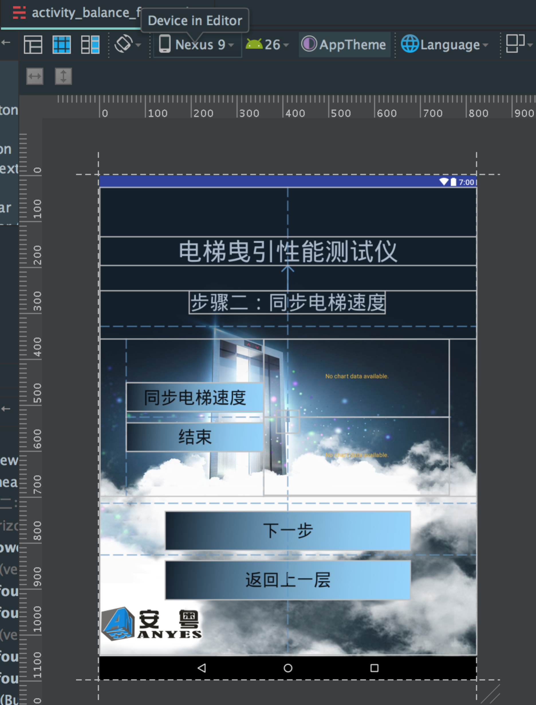

代码片段：

发送信号测试，结束后画图。

@Override  
 protected void onCreate(Bundle savedInstanceState) {  
 super.onCreate(savedInstanceState);  
 setContentView(R.layout.*activity_balance_four*);  
  
 mWifiManager = (WifiManager) getApplicationContext().getSystemService(Context.*WIFI_SERVICE*);  
  
 Button btnBack = (Button) findViewById(R.id.*btnBalanceFourBack*);  
 btnBack.setOnClickListener(new View.OnClickListener() {  
 @Override  
 public void onClick(View view) {  
 startActivity(new Intent(BalanceFourActivity.this, BalanceThreeActivity.class));  
 BalanceFourActivity.this.finish();  
 }  
 });  
  
 Button btnBalanceFive = (Button) findViewById(R.id.*btnBalanceFive*);  
 btnBalanceFive.setOnClickListener(new View.OnClickListener() {  
 @Override  
 public void onClick(View view) {  
 startActivity(new Intent(BalanceFourActivity.this, BalanceFiveActivity.class));  
 BalanceFourActivity.this.finish();  
 }  
 });  
  
 final Button btnSpeedTest = (Button) findViewById(R.id.*balance_four_btnSpeedTest*);  
 final EditText etUDPower = (EditText) findViewById(R.id.*four_et_udPower*);  
 final ProgressBar pb = (ProgressBar) findViewById(R.id.*four_check_pb*);  
  
 ut = new UDPThread(etUDPower, myApp.RecDataList);  
 ut.setRemoteIP("255.255.255.255");  
 ut.setRemotePort(8432);  
 ut.setLocalPort(8432);  
 ut.setRHex(true);  
 ut.setSHex(true);  
  
 mUSPChart = (LineChart) findViewById(R.id.*balance_four_chart_USpeed*);  
 mUSPChart.getDescription().setEnabled(false);  
 mUSPChart.setDrawGridBackground(true);  
 YAxis uLeftAxis = mUSPChart.getAxisLeft();  
 uLeftAxis.setAxisMaximum(6f);  
 uLeftAxis.setAxisMinimum(0f);  
 mUSPChart.getAxisRight().setEnabled(false);  
 XAxis uXAxis = mUSPChart.getXAxis();  
 uXAxis.setEnabled(false);  
 mUSPChart.setNoDataText("");  
 mUSPChart.setBackgroundColor(Color.*WHITE*);  
 mUSPChart.getAxisLeft().setDrawGridLines(false);  
  
 mDSPChart = (LineChart) findViewById(R.id.*balance_four_chart_DSpeed*);  
 mDSPChart.getDescription().setEnabled(false);  
 mDSPChart.setDrawGridBackground(true);  
 YAxis dLeftAxis = mDSPChart.getAxisLeft();  
 dLeftAxis.setAxisMaximum(0f);  
 dLeftAxis.setAxisMinimum(-6f);  
 mDSPChart.getAxisRight().setEnabled(false);  
 XAxis dXAxis = mDSPChart.getXAxis();  
 dXAxis.setEnabled(false);  
 mDSPChart.setNoDataText("");  
 mDSPChart.setBackgroundColor(Color.*WHITE*);  
 mDSPChart.getAxisLeft().setDrawGridLines(false);  
  
 btnSpeedTest.setOnClickListener(new View.OnClickListener() {  
 @Override  
 public void onClick(View view) {  
 if (mWifiManager.getWifiState() != 3) {  
 showAlert("WIFI未连接,请检查！");  
 return;  
 }  
  
 /*  
 if (!mWifiManager.getConnectionInfo().getSSID().equals("\"shaowencai\"")) {  
 showAlert("WIFI连接不正确,请检查！(提示：WIFI名称为\"shaowencai\")");  
 return;  
 }*/  
  
 btnSpeedTest.setEnabled(false);  
 btnEnd.setEnabled(true);  
 etUDPower.getText().clear();  
 myApp.RecDataList.clear();  
// //for test  
// myApp.TestSpeedMethod = "在轿厢测量速度";  
// myApp.RecDataList.add("AA040102"+"111111111111"+"03220322"+"03110311"+"11");  
 if (ut.ConnectSocket()) {  
 pb.setVisibility(View.*VISIBLE*);  
 if (myApp.TestSpeedMethod.equals("在轿厢测量速度")) {  
 ut.SendData("5502040208");  
 //ut.SendData("5501040207");  
 } else {  
 ut.SendData("5503040209");  
 //ut.SendData("5501040207");  
 }  
 } else {  
 showAlert("连接失败，请检查网络设置！");  
 }  
 }  
 });  
  
 btnEnd = (Button) findViewById(R.id.*balance_four_btnEnd*);  
 btnEnd.setEnabled(false);  
  
 btnEnd.setOnClickListener(new View.OnClickListener() {  
 @Override  
 public void onClick(View view) {  
 btnEnd.setEnabled(false);  
 if (myApp.TestSpeedMethod.equals("在轿厢测量速度")) {  
 //ut.SendData("5502040308");  
 } else {  
 //ut.SendData("5503040309");  
 }  
 new Handler().postDelayed(new Runnable() {  
 @Override  
 public void run() {  
 ut.DisConnectSocket();  
 pb.setVisibility(View.*INVISIBLE*);  
 btnSpeedTest.setEnabled(true);  
  
 List<Entry> entriesU = new ArrayList<Entry>();  
 List<Entry> entriesD = new ArrayList<Entry>();  
  
 int i = 0;  
  
 entriesU.add(new Entry(i, 0f));  
 entriesD.add(new Entry(i, 0f));  
  
 for (String s : myApp.RecDataList) {  
 //totally 19 bytes  
 if (s.length() == 38) {  
 for (int j = 0; j <= 4; j++) {  
 i++;  
 if (myApp.TestSpeedMethod.equals("在轿厢测量速度")) {  
 //加速度上行  
 //高位  
 float uHightVal = strToInt(s.substring(28, 30));  
 //低位  
 float uLowVal = strToFloat(s.substring(30, 32));  
 entriesU.add(new Entry(i, (uHightVal + uLowVal)));  
 Log.*i*("BalanceU", "" + (uHightVal + uLowVal));  
  
 //加速度下行  
 //高位  
 float dHightVal = strToInt(s.substring(32, 34));  
 //低位  
 float dLowVal = strToFloat(s.substring(34, 36));  
 entriesD.add(new Entry(i, -(dHightVal + dLowVal)));  
 Log.*i*("BalanceD", dHightVal + dLowVal + "");  
  
 myApp.mUSpeed = uHightVal + uLowVal;  
 myApp.mDSpeed = dHightVal + dLowVal;  
  
 myApp.writeLog(String.*format*("AC_mUSpeed:%s", myApp.mUSpeed));  
 myApp.writeLog(String.*format*("AC_mDSpeed:%s", myApp.mDSpeed));  
  
 LimitLine uLimitLine = new LimitLine(myApp.mUSpeed,""+myApp.mUSpeed);  
 uLimitLine.setLineColor(Color.*DKGRAY*);  
 uLimitLine.setTextColor(Color.*DKGRAY*);  
 uLimitLine.enableDashedLine(10f, 5f, 0f);  
 mUSPChart.getAxisLeft().addLimitLine(uLimitLine);  
  
 LimitLine dLimitLine = new LimitLine(-myApp.mDSpeed,""+myApp.mDSpeed);  
 dLimitLine.setLineColor(Color.*DKGRAY*);  
 dLimitLine.setTextColor(Color.*DKGRAY*);  
 dLimitLine.enableDashedLine(10f, 5f, 0f);  
 mDSPChart.getAxisLeft().addLimitLine(dLimitLine);  
  
 } else {  
 //脉冲上行  
 //高位  
 float uHightVal = strToInt(s.substring(20, 22));  
 //低位  
 float uLowVal = strToFloat(s.substring(22, 24));  
 entriesU.add(new Entry(i, (uHightVal + uLowVal)));  
 Log.*i*("BalanceU", "" + (uHightVal + uLowVal));  
  
 //脉冲下行  
 //高位  
 float dHightVal = strToInt(s.substring(24, 26));  
 //低位  
 float dLowVal = strToFloat(s.substring(26, 28));  
 entriesD.add(new Entry(i, -(dHightVal + dLowVal)));  
 Log.*i*("BalanceD", dHightVal + dLowVal + "");  
  
 myApp.mUSpeed = uHightVal + uLowVal;  
 myApp.mDSpeed = dHightVal + dLowVal;  
  
 myApp.writeLog(String.*format*("MC_mUSpeed:%s", myApp.mUSpeed));  
 myApp.writeLog(String.*format*("MC_mDSpeed:%s", myApp.mDSpeed));  
  
 LimitLine uLimitLine = new LimitLine(myApp.mUSpeed,""+myApp.mUSpeed);  
 uLimitLine.setLineColor(Color.*DKGRAY*);  
 uLimitLine.setTextColor(Color.*DKGRAY*);  
 mUSPChart.getAxisLeft().addLimitLine(uLimitLine);  
  
 LimitLine dLimitLine = new LimitLine(-myApp.mDSpeed,""+myApp.mDSpeed);  
 dLimitLine.setLineColor(Color.*DKGRAY*);  
 dLimitLine.setTextColor(Color.*DKGRAY*);  
 mDSPChart.getAxisLeft().addLimitLine(dLimitLine);  
 }  
 }  
 }  
 }  
  
 entriesU.add(new Entry(i+1, 0f));  
 entriesD.add(new Entry(i+1, 0f));  
  
 mUSPChart.setData(generateLineData("速度上行", entriesU));  
 mUSPChart.animateX(1000);  
  
 mDSPChart.setData(generateLineData("速度下行", entriesD));  
 mDSPChart.animateX(1000);  
  
 //btnEnd.setEnabled(true);  
 }  
 }, 3000);  
 }  
 });  
 }  
  
 protected LineData generateLineData(String label, List<Entry> entries) {  
  
 ArrayList<ILineDataSet> sets = new ArrayList<ILineDataSet>();  
 LineDataSet ds1 = new LineDataSet(entries, label);  
 //LineDataSet ds2 = new LineDataSet(FileUtils.loadEntriesFromAssets(getActivity().getAssets(), "cosine.txt"), "Cosine function");  
  
 ds1.setMode(LineDataSet.Mode.*HORIZONTAL_BEZIER*);  
 ds1.setLineWidth(3f);  
 //ds2.setLineWidth(2f);  
  
 ds1.setDrawCircles(false);  
 //ds2.setDrawCircles(false);  
  
 ds1.setColor(Color.*RED*);  
 //ds2.setColor(ColorTemplate.VORDIPLOM_COLORS[1]);  
  
 ds1.setValueFormatter(new IValueFormatter() {  
 @Override  
 public String getFormattedValue(float value, Entry entry, int dataSetIndex, ViewPortHandler viewPortHandler) {  
 //return "" + value;  
 return "";  
 }  
 });  
  
 // load DataSets from textfiles in assets folders  
 sets.add(ds1);  
 //sets.add(ds2);  
  
 LineData d = new LineData(sets);  
 //d.setValueTypeface(tf);  
 return d;  
 }

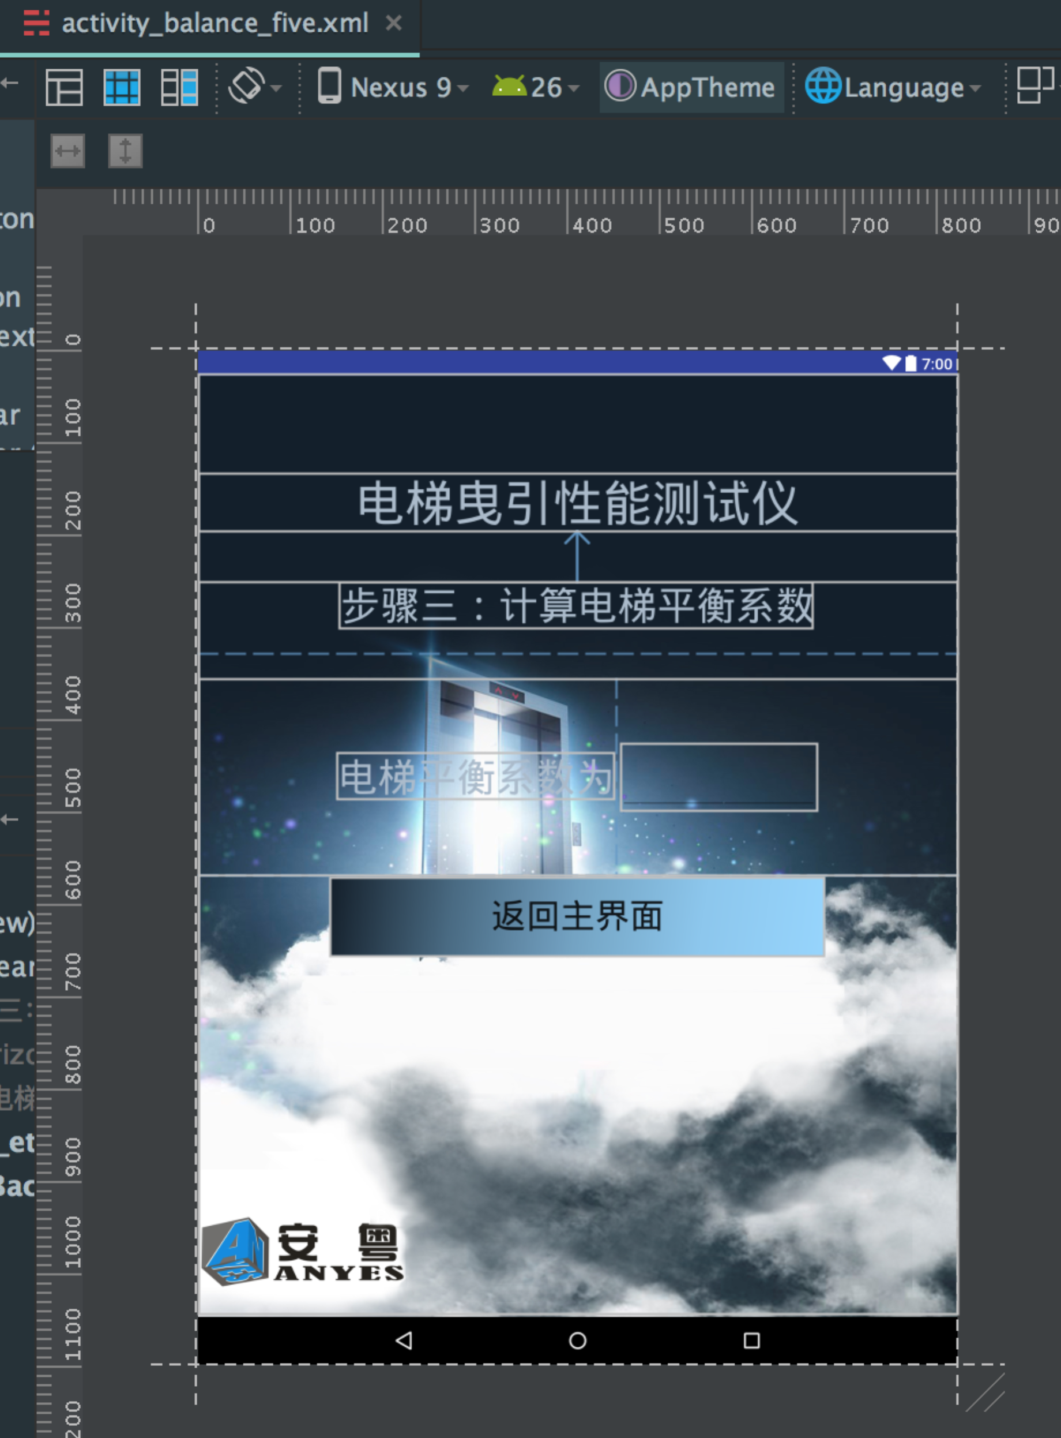

代码片段：

计算并保存平衡系数。

@Override  
protected void onCreate(Bundle savedInstanceState) {  
 super.onCreate(savedInstanceState);  
 setContentView(R.layout.*activity_balance_five*);  
  
 Button btnBack = (Button) findViewById(R.id.*btnBalanceFiveBack*);  
 btnBack.setOnClickListener(new View.OnClickListener() {  
 @Override  
 public void onClick(View view) {  
 startActivity(new Intent(BalanceFiveActivity.this, MainActivity.class));  
 BalanceFiveActivity.this.finish();  
 }  
 });  
  
 EditText etBalanceFactor = (EditText) findViewById(R.id.*balance_five_etBalanceFactor*);  
 etBalanceFactor.setTextColor(Color.*RED*);  
  
 ACache.*get*(BalanceFiveActivity.this).put(myApp.mNumber, myApp.getBalanceFactor());  
 ACache.*get*(BalanceFiveActivity.this).put(myApp.mDate, myApp.getBalanceFactor());  
  
 etBalanceFactor.setText(String.*valueOf*(myApp.getBalanceFactor()));  
}

#### 1.2.2.2通讯检测

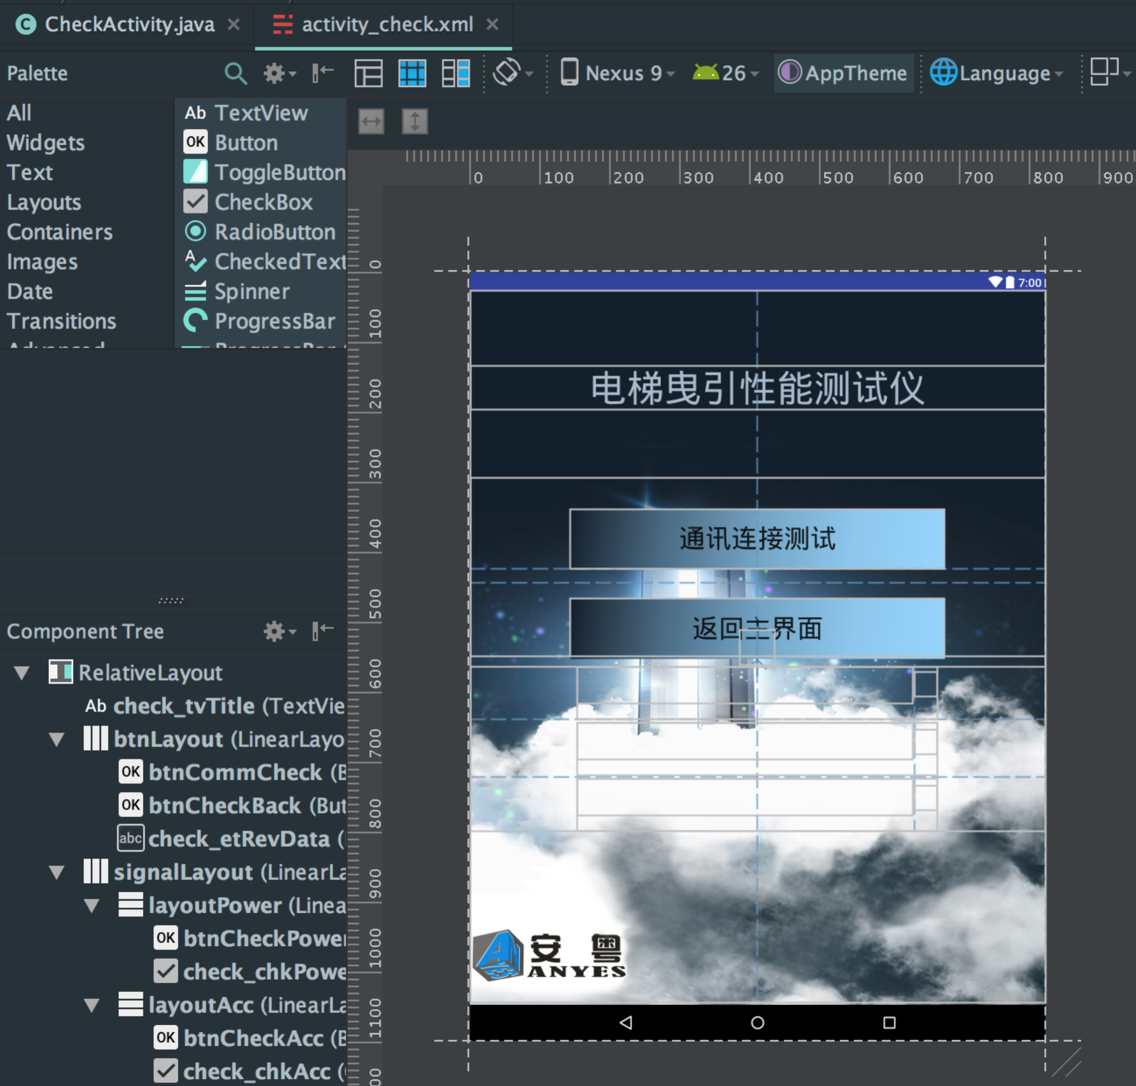

发送检测命令，测试成功显示通过界面。

代码片段：

ut.SendData("5500040105");

//功率信号

if (rd.equals("AA04010106")) {  
 mPowerRecv = true;  
}

//速度信号  
if (rd.equals("AA04020107")) {  
 mAccRecv = true;  
}

//脉冲信号  
if (rd.equals("AA04030108")) {  
 mPluRecv = true;  
}

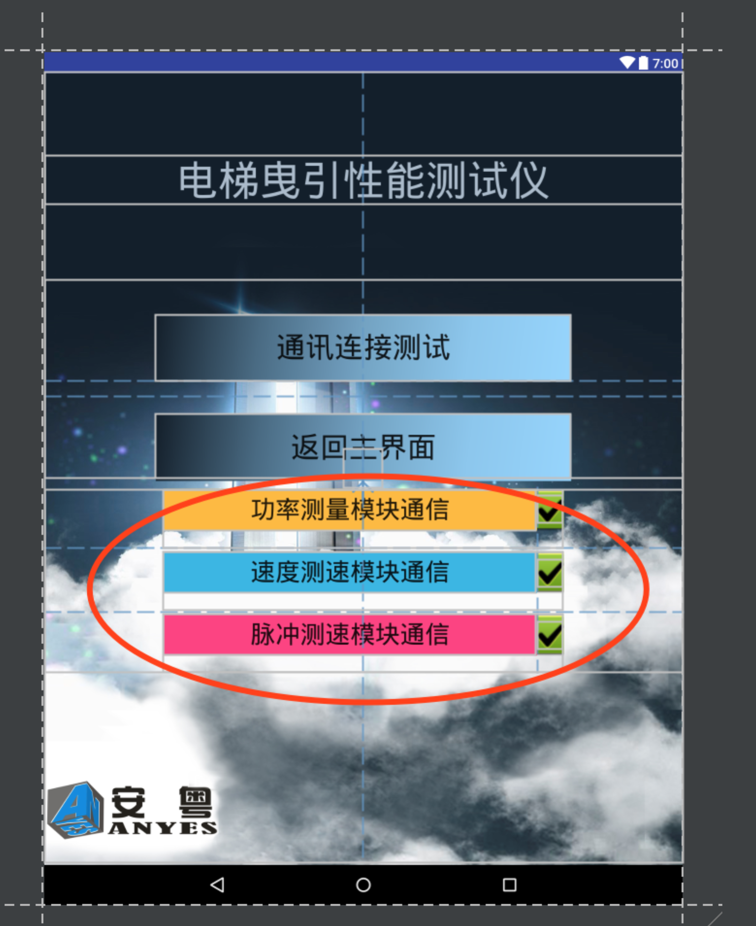

#### 1.2.2.3数据查询

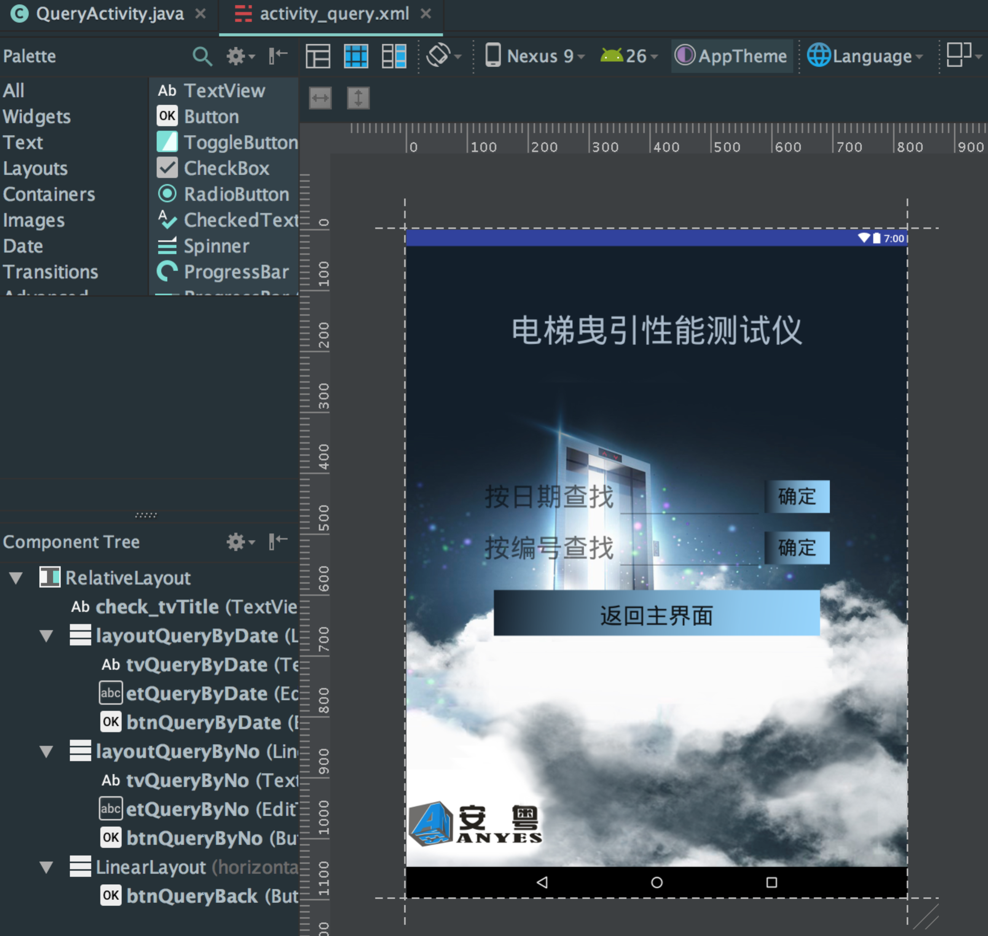

按日期查找平衡系数：从缓存记录里面查找，按照yyyyMMdd格式查找。

按编号查找平衡系数：从缓存记录里面查找，按照录入编号查找。

### 1.2.3辅助模块及公式计算

1. ACache.java

缓存操作类。

1. CrashHandler.java

系统运行异常日志记录。

1. UDPThread.java

跟设备UDP通讯类，进行数据收发。

1. BaseActivity.java

模块基类，主要是设置线程策略安全，数据转换，界面全屏，弹出消息框，以及后退退出系统。

1. 公用函数，输入框自动弹出和收起软键盘，在每个Activity里重写。

@Override  
public boolean dispatchTouchEvent(MotionEvent ev) {  
 if (ev.getAction() == MotionEvent.*ACTION_DOWN*) {  
 View v = getCurrentFocus();  
 if (isShouldHideInput(v, ev)) {  
  
 InputMethodManager imm = (InputMethodManager) getSystemService(Context.*INPUT_METHOD_SERVICE*);  
 if (imm != null) {  
 imm.hideSoftInputFromWindow(v.getWindowToken(), 0);  
 }  
 }  
 return super.dispatchTouchEvent(ev);  
 }  
 // 必不可少，否则所有的组件都不会有TouchEvent了  
 if (getWindow().superDispatchTouchEvent(ev)) {  
 return true;  
 }  
 return onTouchEvent(ev);  
}  
  
boolean isShouldHideInput(View v, MotionEvent event) {  
 if (v != null && (v instanceof EditText)) {  
 int[] leftTop = {0, 0};  
 //获取输入框当前的location位置  
 v.getLocationInWindow(leftTop);  
 int left = leftTop[0];  
 int top = leftTop[1];  
 int bottom = top + v.getHeight();  
 int right = left + v.getWidth();  
 if (event.getX() > left && event.getX() < right  
 && event.getY() > top && event.getY() < bottom) {  
 // 点击的是输入框区域，保留点击EditText的事件  
 return false;  
 } else {  
 return true;  
 }  
 }  
 return false;  
}

1. MyApplication.java

打印日志和全局变量保存。

public float getBalanceFactor() {  
 if (mLoad > 0) {  
  
 writeLog("=======getBalanceFactor Start=========");  
 writeLog(String.*format*("mUPower:%s", mUPower)); //上行功率  
 writeLog(String.*format*("mUPowerFactor:%s", mUPowerFactor)); //上行功率因素  
 writeLog(String.*format*("mDSpeed:%s", mDSpeed)); //下行速度  
 writeLog(String.*format*("mDPower:%s", mDPower)); //下行功率  
 writeLog(String.*format*("mDPowerFactor:%s", mDPowerFactor)); //下行功能因素  
 writeLog(String.*format*("mUSpeed:%s", mUSpeed)); //上行速度  
 writeLog(String.*format*("mLoad:%s", mLoad)); //载荷  
 writeLog(String.*format*("mIsManualSpeed:%s", mIsManualSpeed)); //是否手动计算  
 writeLog(String.*format*("mManualSpeed:%s", mManualSpeed)); //手动输入额定速度  
 writeLog(String.*format*("mTractProp:%s", mTractProp)); //mTractProp参数  
  
 //remove the power factor  
 if (!mIsManualSpeed) {  
 writeLog(String.*format*("(%s + %s) * %s * %s " +  
 "/ (2 * 9.81f * %s * %s)", mUPower, mDPower, mElevator, mTractProp, mLoad, mUSpeed));  
 } else {  
 writeLog(String.*format*("(%s + %s) * %s * %s " +  
 "/ (2 * 9.81f * %s * %s)", mUPower, mDPower, mElevator, mTractProp, mLoad, mManualSpeed));  
 }  
  
 writeLog("=======getBalanceFactor End=========");  
 if (!mIsManualSpeed) {  
 if (mUSpeed > 0) {  
 return (mUPower + mDPower) * mElevator * mTractProp //自动公式  
 / (2 * 9.81f * mLoad * mUSpeed);  
 } else {  
 return 0;  
 }  
 } else {  
 return (mUPower + mDPower) * mElevator * mTractProp //手动公式  
 / (2 * 9.81f * mLoad * mManualSpeed);  
 }  
 } else {  
 return 0;  
 }

}

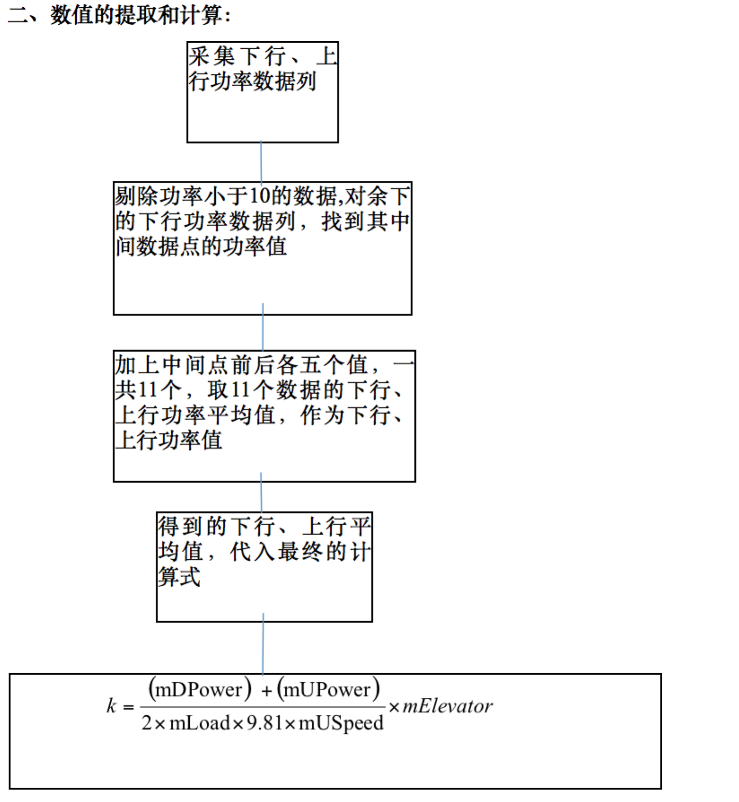

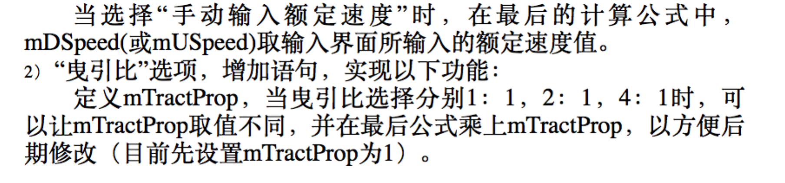

# 2.部署

## 2.1环境搭建

### 2.1.1下载Android Studio

地址： <http://www.androiddevtools.cn>

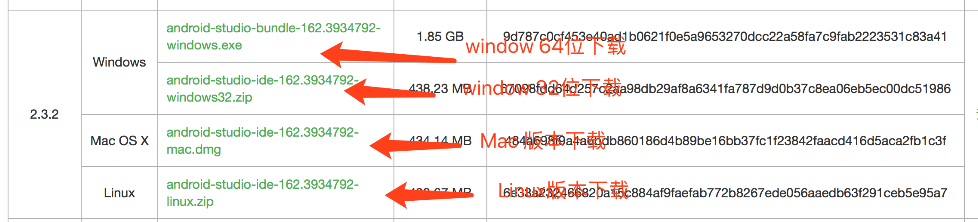

选择合适的系统版本下载

### 2.1.2 SDK下载

打开Android Studio



选择Configure->SDK Manager

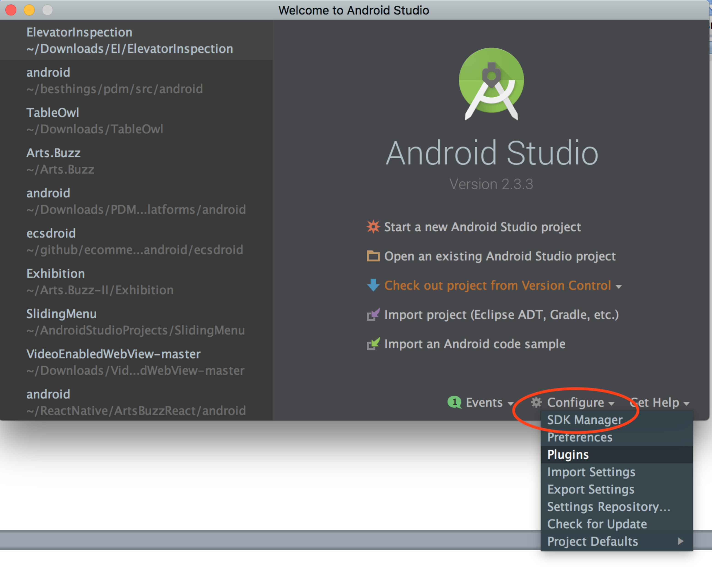  
勾选Android API版本，点OK开始安装

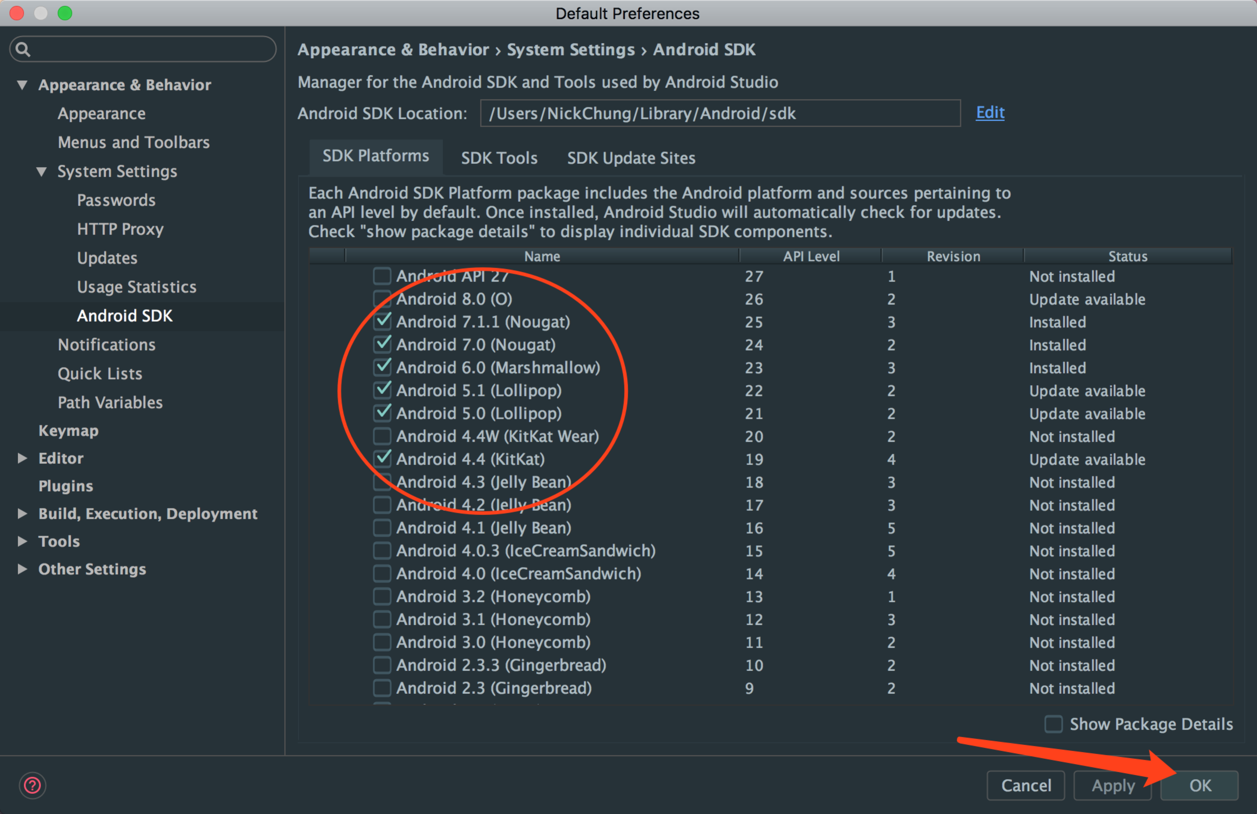

如果下载不了，需要代理，设置如下：

Android SDK在线更新镜像服务器

郑州大学开源镜像站:  mirrors.zzu.edu.cn 端口：80

**使用方法：**

1. 启动 Android SDK Manager ，打开主界面，依次选择『**Tools**』、『**Options...**』，弹出『**Android SDK Manager - Settings**』窗口；
2. 在『**Android SDK Manager - Settings**』窗口中，在『**HTTP Proxy Server』和『HTTP Proxy Port**』输入框内填入上面镜像服务器地址(**不包含http://**，如下图)和端口，并且选中『**Force https://... sources to be fetched using http://...**』复选框。设置完成后单击『**Close**』按钮关闭『**Android SDK Manager - Settings**』窗口返回到主界面；
3. 依次选择『**Packages**』、『**Reload**』。

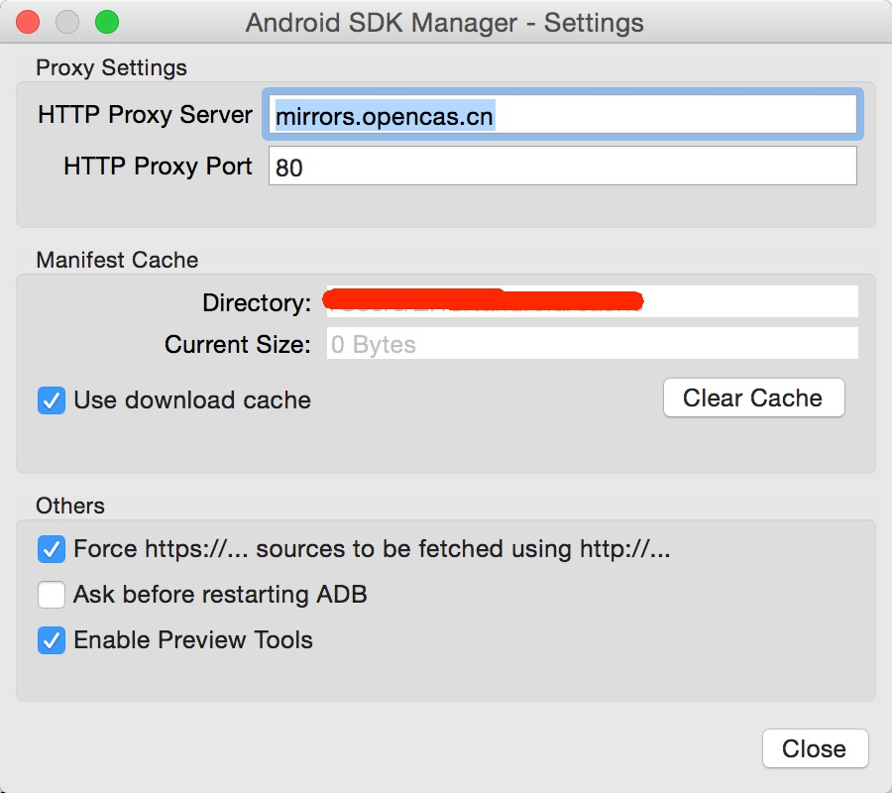

再重新进行下载

## 2.2源码编译

下载源码，解压

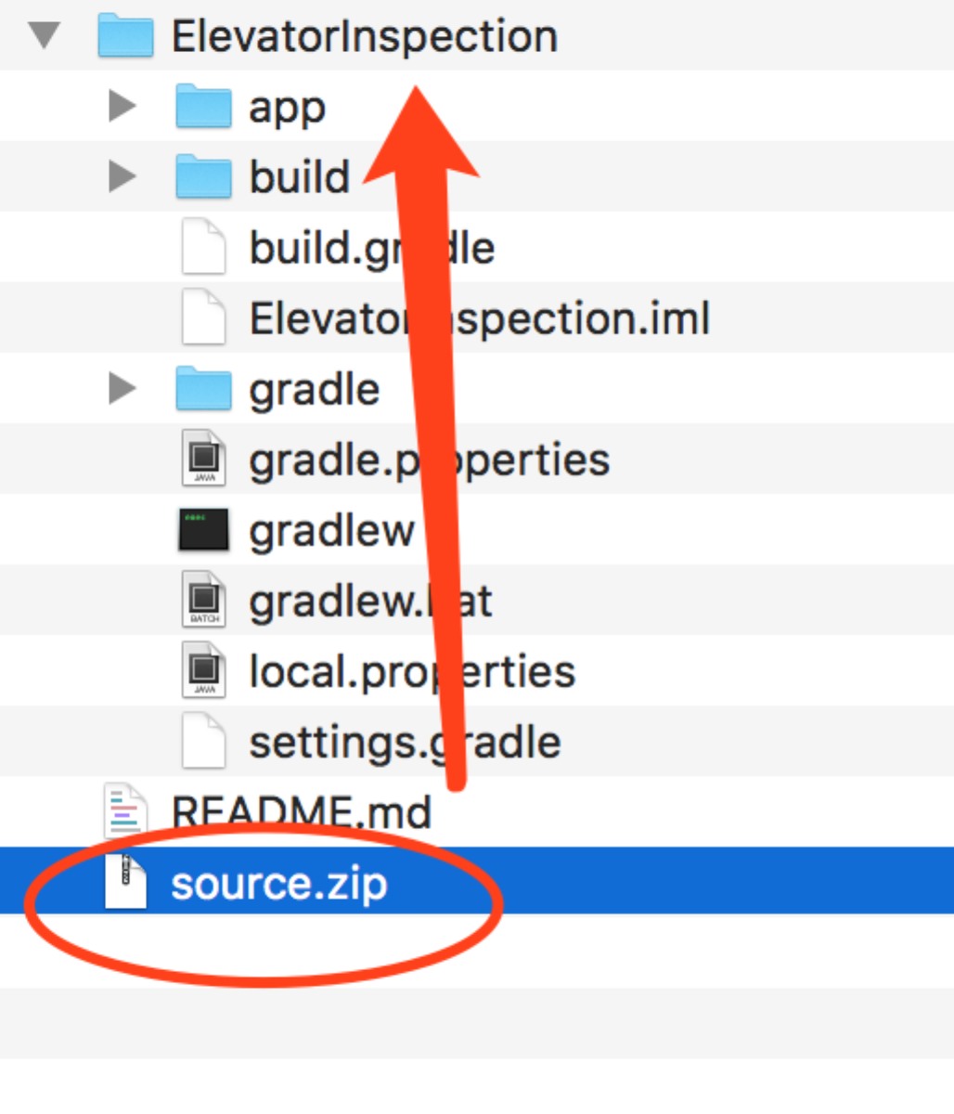

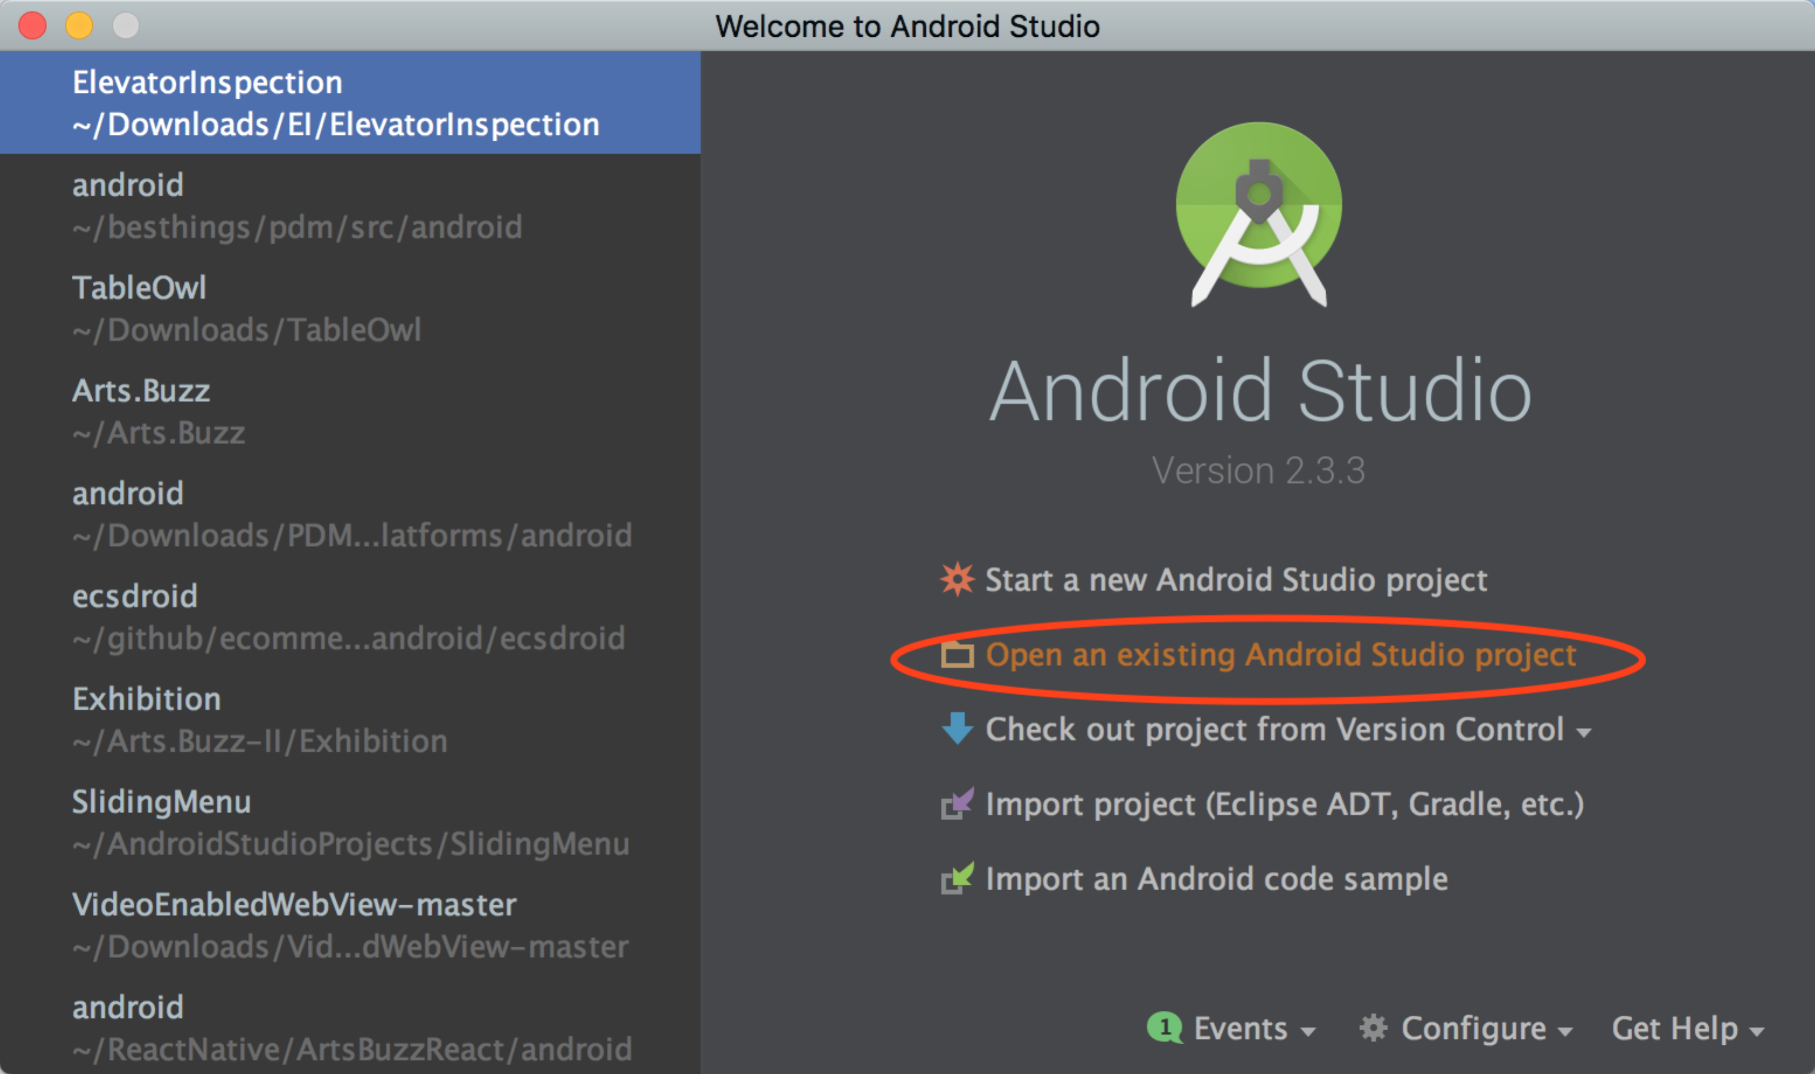

打开项目

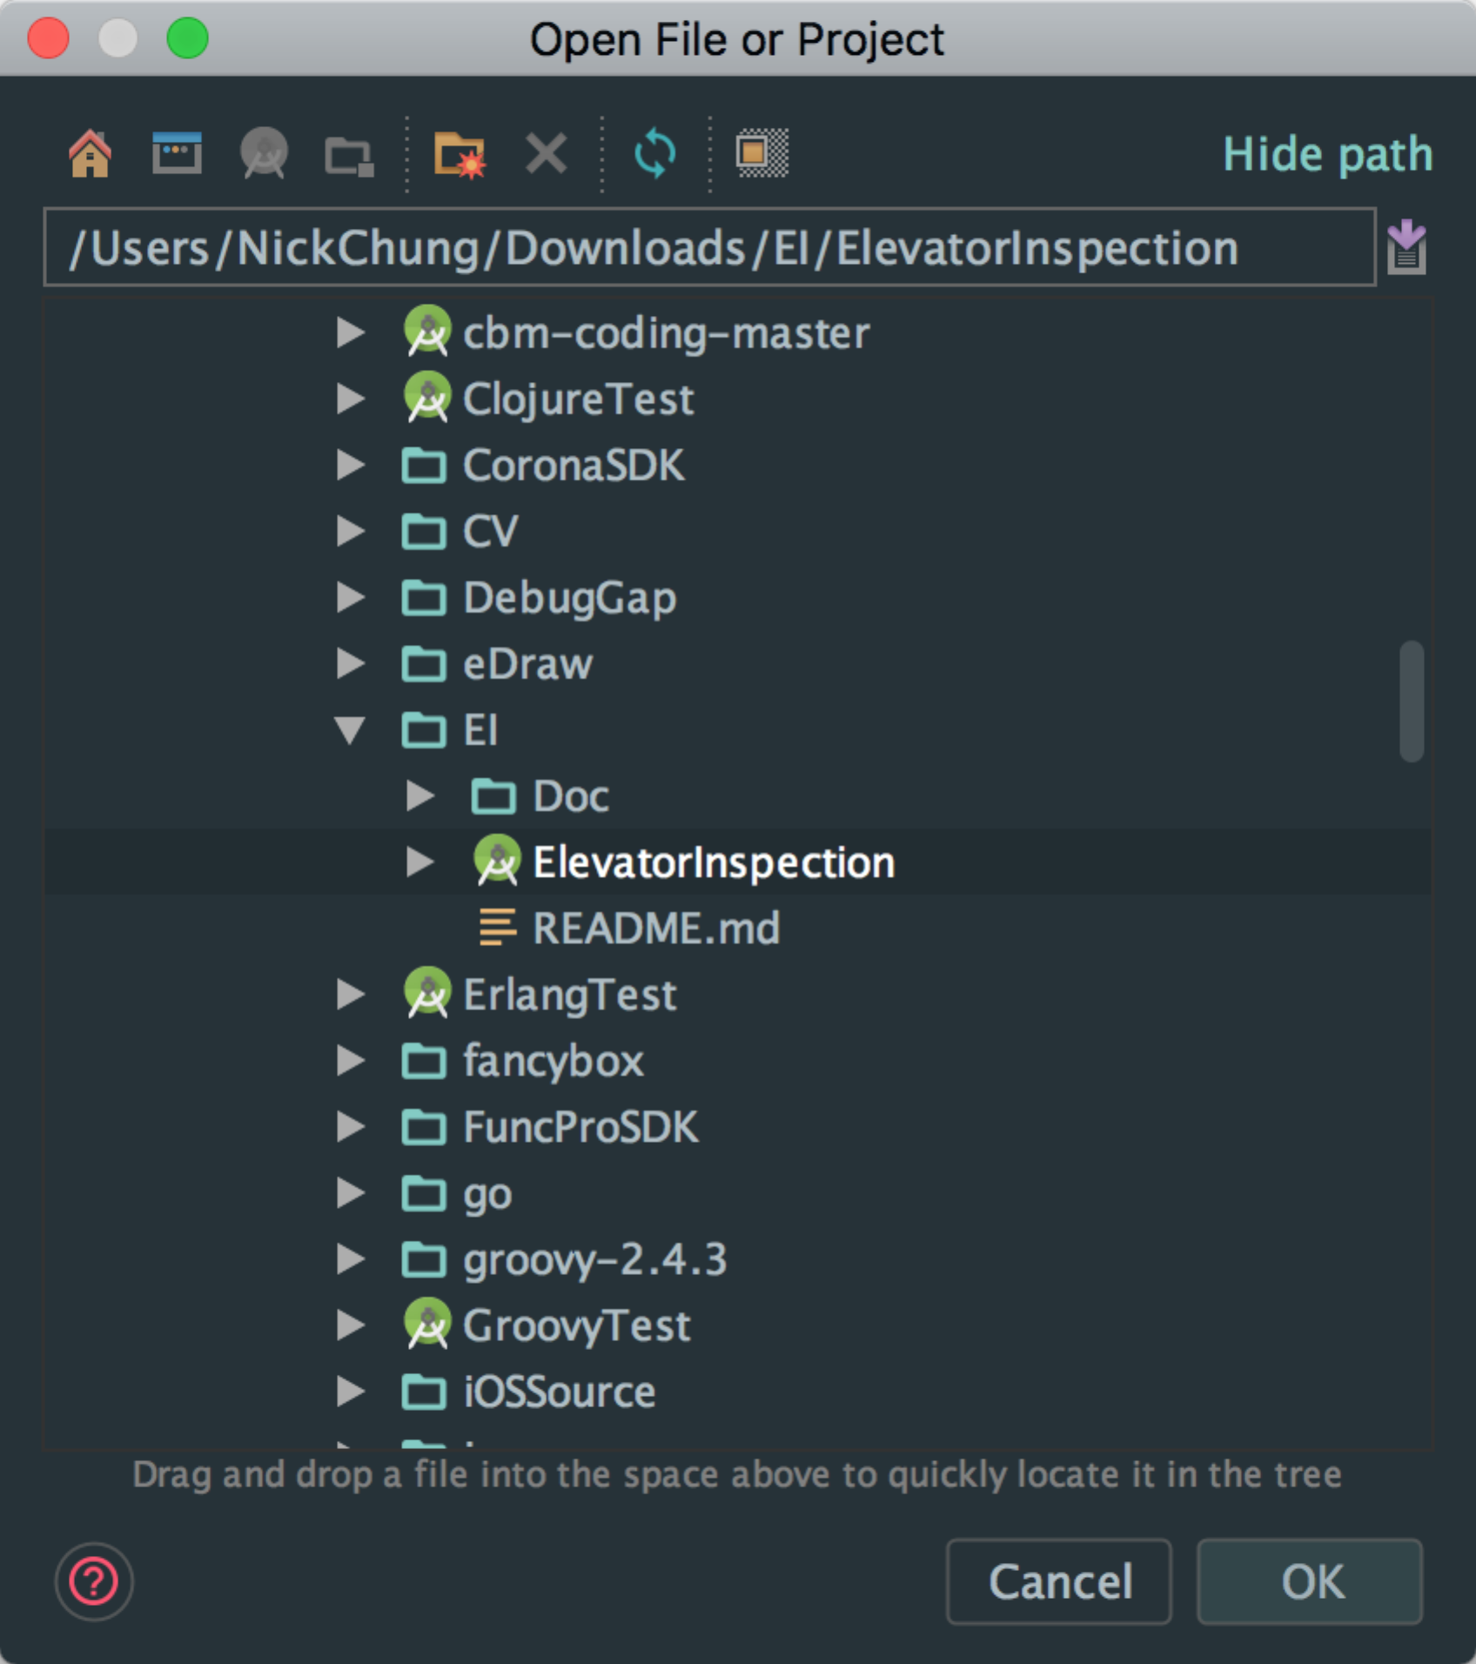

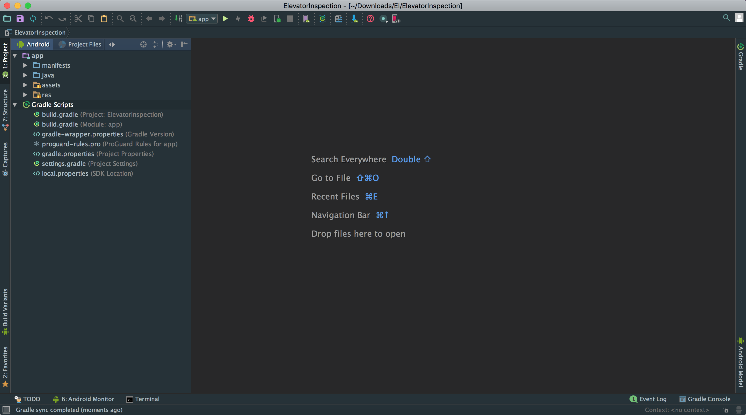

进行源码编译

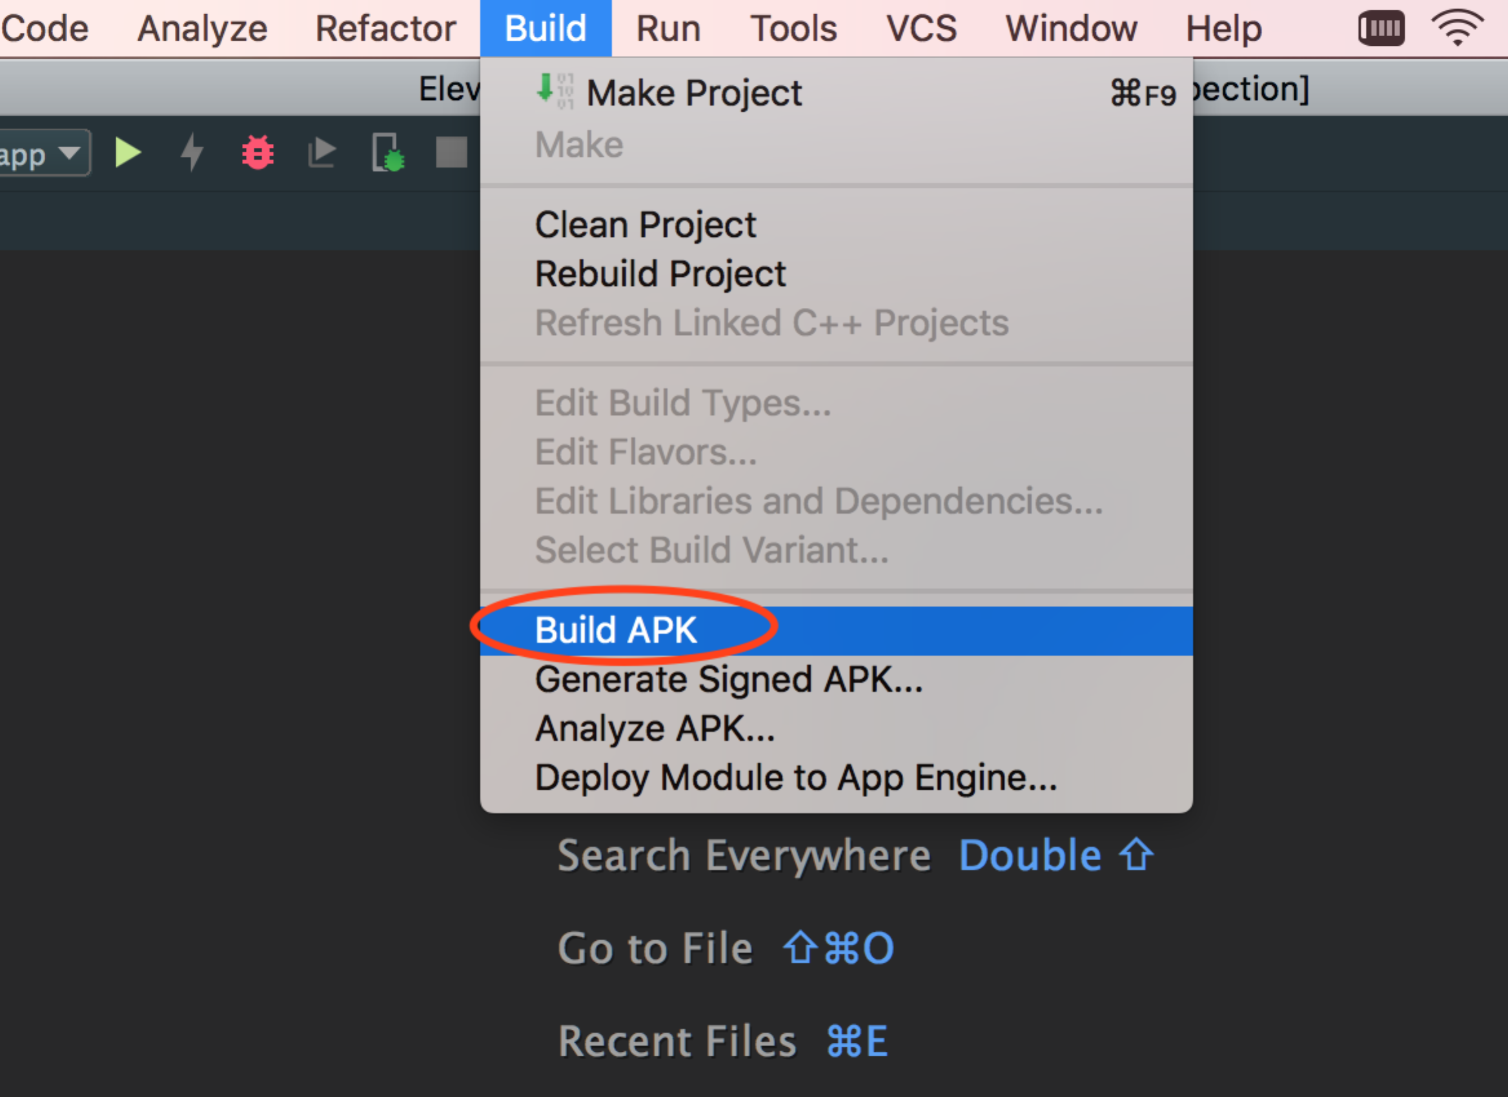

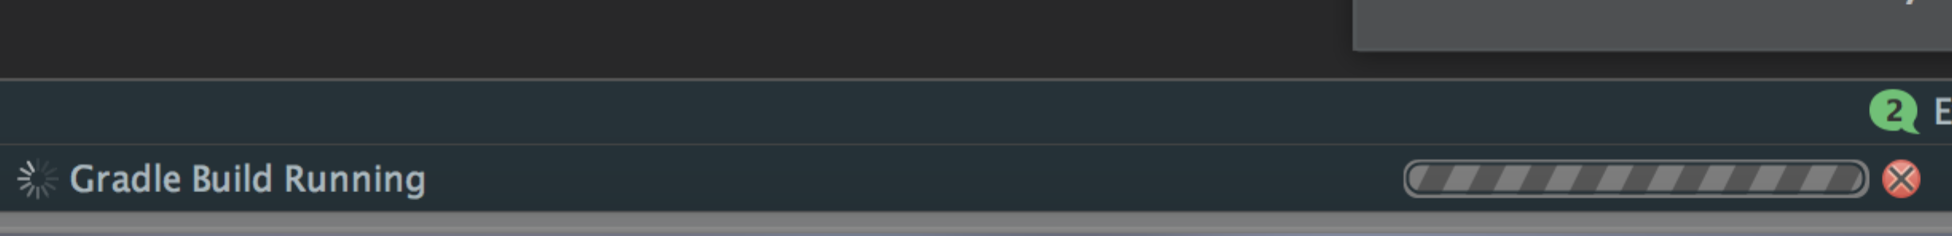

生成APP

